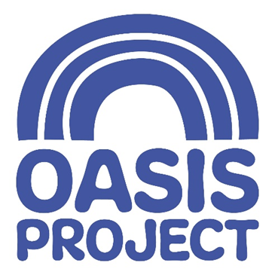

Family Team Recovery Worker
Application Pack

Salary: £28,426 FTE (£26,530 for 35 hours)
Location: Brighton & Hove
Contract type: Fixed-term (1 year), Part Time
Hours: 35 hours
Application Link: https://oasisproject.current-vacancies.com/Jobs/Advert/4293560?cid=3426



Contents:
- Introduction
- About Oasis Project
  - Our Services
  - Our Values
  - Employee Benefits
- The Recruitment Process
- Job Description
- Person Specification

Introduction
Thank you for your interest in Oasis Project and the role of Family Team Recovery Worker. This pack will tell you a little about the organisation, the role, and how to apply.

- Please apply by sending a CV and covering letter via IRIS, our chosen recruitment platform using this link: https://oasisproject.current-vacancies.com/Jobs/Advert/4293560?cid=3426
- The closing date is Tuesday 1st September 9am.
- Interviews will be held in person during the weeks commencing 7 and 14 September 2026.
- The interview process will involve a panel interview.

About Oasis Project
Oasis was founded in 1997 by a group of women with lived experience of drug and alcohol problems, who felt their needs were not met in mainstream treatment services. Over nearly 30 years we have built extensive experience of providing support for women in Brighton and Hove with a drug or alcohol problem and our adult services form part of the city’s drug and alcohol treatment delivery system. Alongside this, we offer services for children and young people affected by parental substance use, including a creche and specialist therapy service.

Our Values
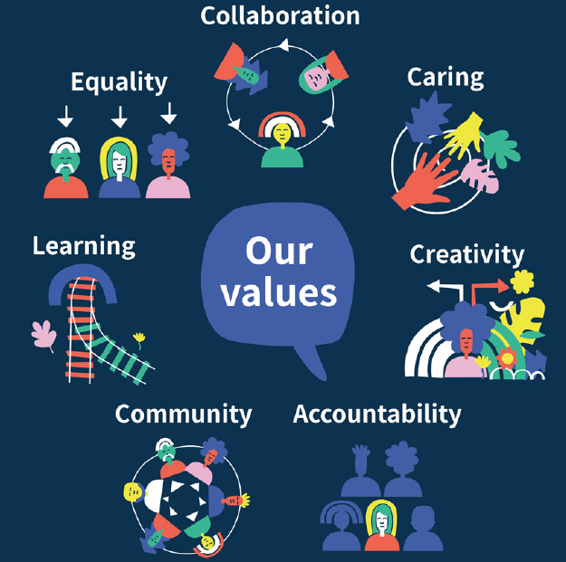

Our services
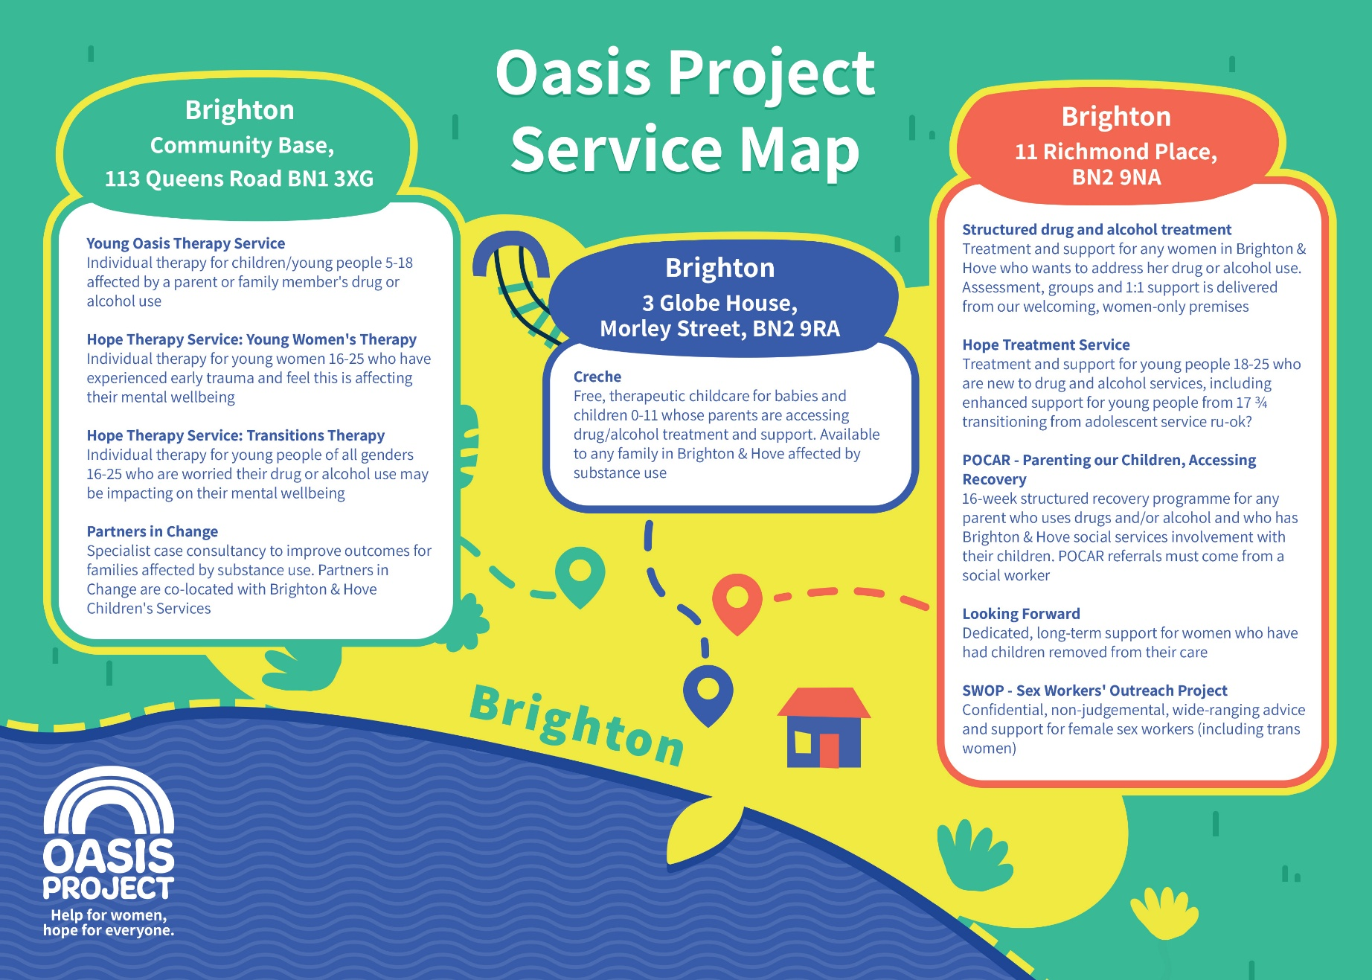

Working with Oasis Project
We value our staff and take their wellbeing seriously. Taking care of staff means renumerating them well for the work they do, and offering additional support and rewards alongside a monthly salary.

Employee Benefits
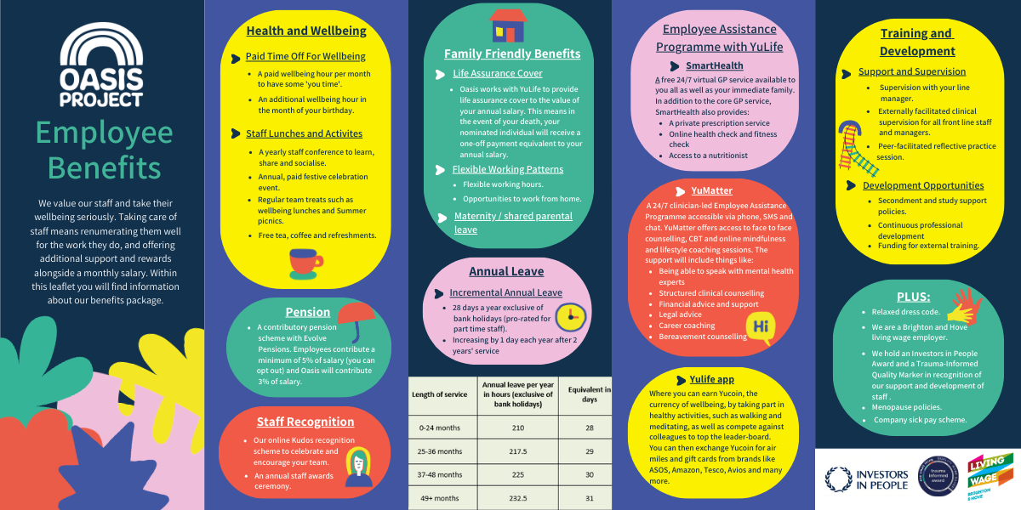

The Recruitment Process
At Oasis Project we are committed to providing the best possible recruitment experience, including working to remove barriers to equal opportunity at each stage of the recruitment process.

Our commitment to you is that:

- We will treat you in a polite, helpful and friendly manner at all times.
- Information that you provide will be treated as confidential and will be seen only by certain people involved in the recruitment process.

- We will ask you to complete an equal opportunities questionnaire – this information is only used for monitoring purposes.

- We will endeavor to make any reasonable adjustments to the interview process to enable you to fully participate

- We will communicate with you clearly, and as quickly as possible at each stage of the recruitment process

- As far as possible, we make it clear in the job advertisement when the interviews will be held.

- A decision will be made as soon as possible after interviews and you will be informed of the outcome

- Unsuccessful interviewees will be offered feedback.

Job Description

Role profile:
Role title: Family Team Recovery Worker | Reports to: Family Team Leader
Team: Adult Services/Family Team

Hours: Part-time 35 hours per week

Salary: £28,426 FTE (£26,530 for 35 hours)

Contract type: 1 year FTC

Location: Brighton & Hove (including some outreach)

Purpose of the role

This is an exciting opportunity to make real impact within an established, award-winning, innovative voluntary sector organisation.
Oasis Project provides structured drug and alcohol treatment and recovery services for women, children and families affected by substance use.
As a Family Team Recovery Worker, you will work within a specialist, trauma-informed, gender-responsive and child-centred service delivering structured interventions to support women and families to achieve positive and lasting change. This includes partnership working to deliver Oasis Project’s POCAR programme (Parenting Our Children, Accessing Recovery).
You will work directly with mothers and some fathers impacted by substance use, including those involved with Children’s Social Care. The role requires close multi-agency working, participation in safeguarding processes, and the delivery of both individual and group-based interventions.

About the role – what to expect

This is a rewarding but demanding role working with families experiencing complex needs, including substance use, trauma, domestic abuse, and safeguarding concerns.
You will:
- Work closely with Children’s Social Care and contribute to child protection processes
- Work closely with external partners and internal colleagues to manage risk and respond to safeguarding concerns confidently
- Undertake lone working and community-based visits
- Maintain professional boundaries while building trusting, supportive relationships

Key Relationships

Internal
- Family Team Leader
- Adult Services colleagues
- Children & Young People’s Services teams
- Administration and support services
External
- Children’s Social Care
- Health and substance use services
- Multi-agency safeguarding partners
- Community and voluntary sector organisations

This list is not exhaustive
Key Responsibilities

Client Service Delivery
- Conduct comprehensive assessments for individuals referred to the service
- Manage a caseload of approximately 30–40 women in structured treatment
- Deliver structured 1:1 interventions using a keywork approach
- Facilitate and co-facilitate psychosocial recovery groups for women and some men
- Support parents to address problematic substance use and its impact on parenting and family life
- Work holistically to support clients experiencing complex needs including early trauma, mental health and domestic abuse
- Promote recovery, resilience and engagement with wider community services

Safeguarding and Risk Management
- Work collaboratively with Children’s Social Care to support safeguarding outcomes
- Participate in child protection conferences, core groups and multi-agency meetings
- Identify, assess and support the management of risk relating to children and adults
- Attend internal risk and safeguarding meetings
- Maintain professional curiosity and respond appropriately to safeguarding concerns
- Ensure safeguarding practice aligns with organisational policy and statutory guidance

Partnership Working
- Develop effective working relationships with internal and external partners
- Contribute to coordinated multi-agency responses to complex family needs
- Support joint working to improve outcomes for women, children and families
- Signpost and refer clients to appropriate services, including housing, mental health and recovery support

Service Quality, Recording and Reporting
- Maintain accurate, timely and high-quality case records
- Complete risk assessments, recovery plans and Treatment Outcome Profiles (TOPs)
- Produce clear, analytical and professional reports for safeguarding meetings and POCAR interventions
- Ensure all data is recorded in line with organisational, contractual and regulatory requirements
- Contribute to service monitoring, evaluation and continuous improvement

Professional Practice and Team Contribution
- Engage in regular supervision and reflective practice
- Work collaboratively as part of a multidisciplinary team, supporting and covering for colleagues as required
- Adhere to professional boundaries at all times
- Contribute to a positive, inclusive and trauma-informed team culture
- Participate in training and continuous professional development
- Uphold the values and ethos of Oasis Project

Role Boundaries

The post holder is not responsible for:
- Holding statutory safeguarding decision-making authority
- Managing service budgets
- Delivering specialist clinical or therapeutic interventions requiring additional professional registration

Completing your application
To apply for this role, please submit your CV and a covering letter of no more than two sides (font size 11) via IRIS – our chosen recruitment platform. The link to apply is: https://oasisproject.current-vacancies.com/Jobs/Advert/4293560?cid=3426. In your covering letter, please explain how your skills, experience and knowledge meet the requirements of the role. We encourage you to read the job description and person specification carefully and to structure your supporting statement clearly against the stated criteria.

Recruitment checks

References

We require two references. Referees will not be contacted without your prior consent, but two satisfactory references must be received before any offer of employment can be confirmed. Where possible, please provide an email address for each referee, as this helps us to process references efficiently.

Eligibility to work in the UK

We require you to provide appropriate ID documentation that proves your eligibility to work
in the UK or the appropriate share code to demonstrate settled status.

Occupational health check

You will be asked to complete an online medical questionnaire, via our occupational health
providers. Our occupational health experts will confirm to Oasis Project your fitness
to undertake the role, including if adjustments may be required, based on the
information that you have disclosed.

Ex-offenders / Disclosure and Barring Service (DBS) Checks

All applicants are required to disclose details of any unspent convictions in accordance
with the Rehabilitation of Offenders Act 1974. Any disclosure of an unspent conviction will
not automatically disqualify your application unless the nature of the offence renders you
unsuitable for the role. All such disclosures will be considered on an individual basis.
Please consider this in your covering letter.

As your employment at Oasis will include working with vulnerable adults you will be required to
undertake a DBS check.

We wish you success with your application.

