

Finance Manager
Application Pack

Salary: £40,000 FTE (£16,000 actual based on 15 hours per week) or freelance equivalent by agreement
Location: Brighton - Hybrid
Contract type: Permanent, Part Time

Hours: 15 hours per week (PAYE or freelance considered)

Introduction
Thank you for your interest in Oasis Project and the role of Finance Manager. This pack will tell you a little about the organisation, the role, and how to apply.

In short:
- Please apply by sending a CV and covering letter via the IRIS platform
- The closing date is Monday 5 January 2026 at 9am.
- Interviews will be held in person week commencing 12 January 2026.
- The interview process will involve a series of competency-based interview questions.

We would like the successful candidate to start as soon as possible.

About Oasis Project
Oasis was founded in 1997 by a group of women with lived experience of drug and alcohol problems, who felt their needs were not met in mainstream treatment services. We have over 28 years’ experience of providing support to women in Brighton and Hove with a drug or alcohol problem and our adult services form part of the city’s drug and alcohol treatment delivery system. Alongside this, we offer services for children and young people affected by parental substance misuse, including a creche and therapy service.

Our services

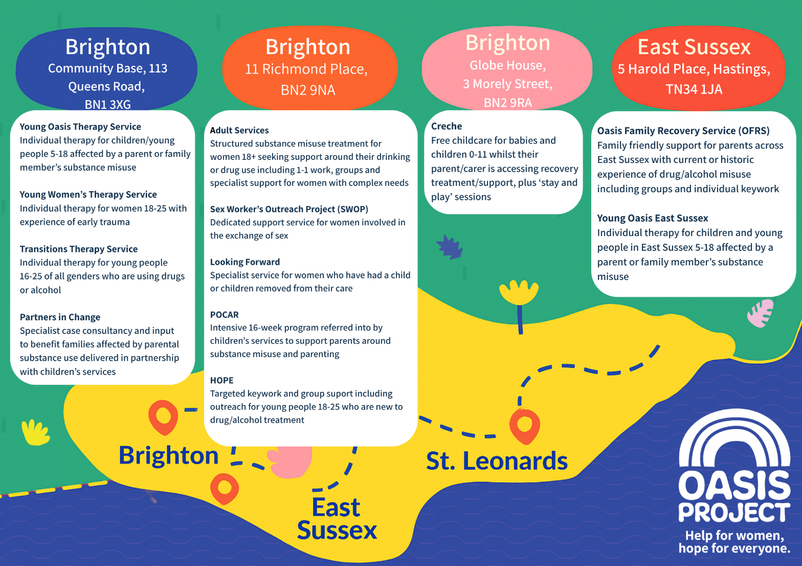

Our Values


Working with Oasis Project
We value our staff and take their wellbeing seriously. Taking care of staff means renumerating them well for the work they do, and offering additional support and rewards alongside a monthly salary.

Employee Benefits

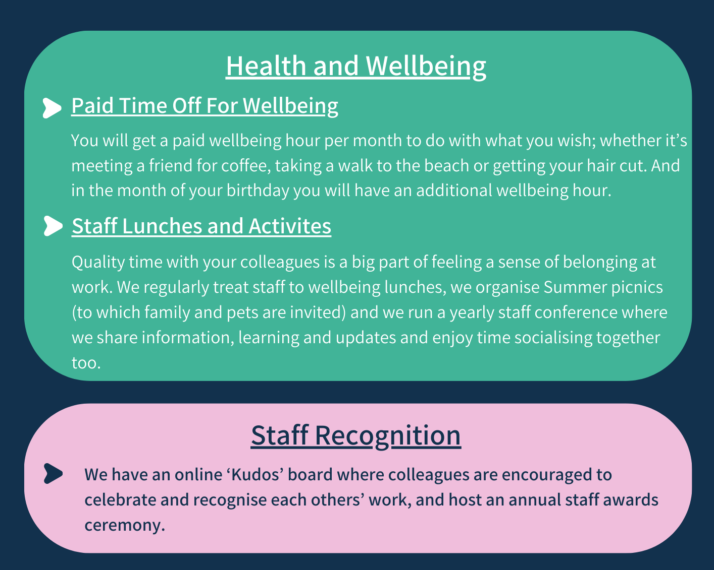
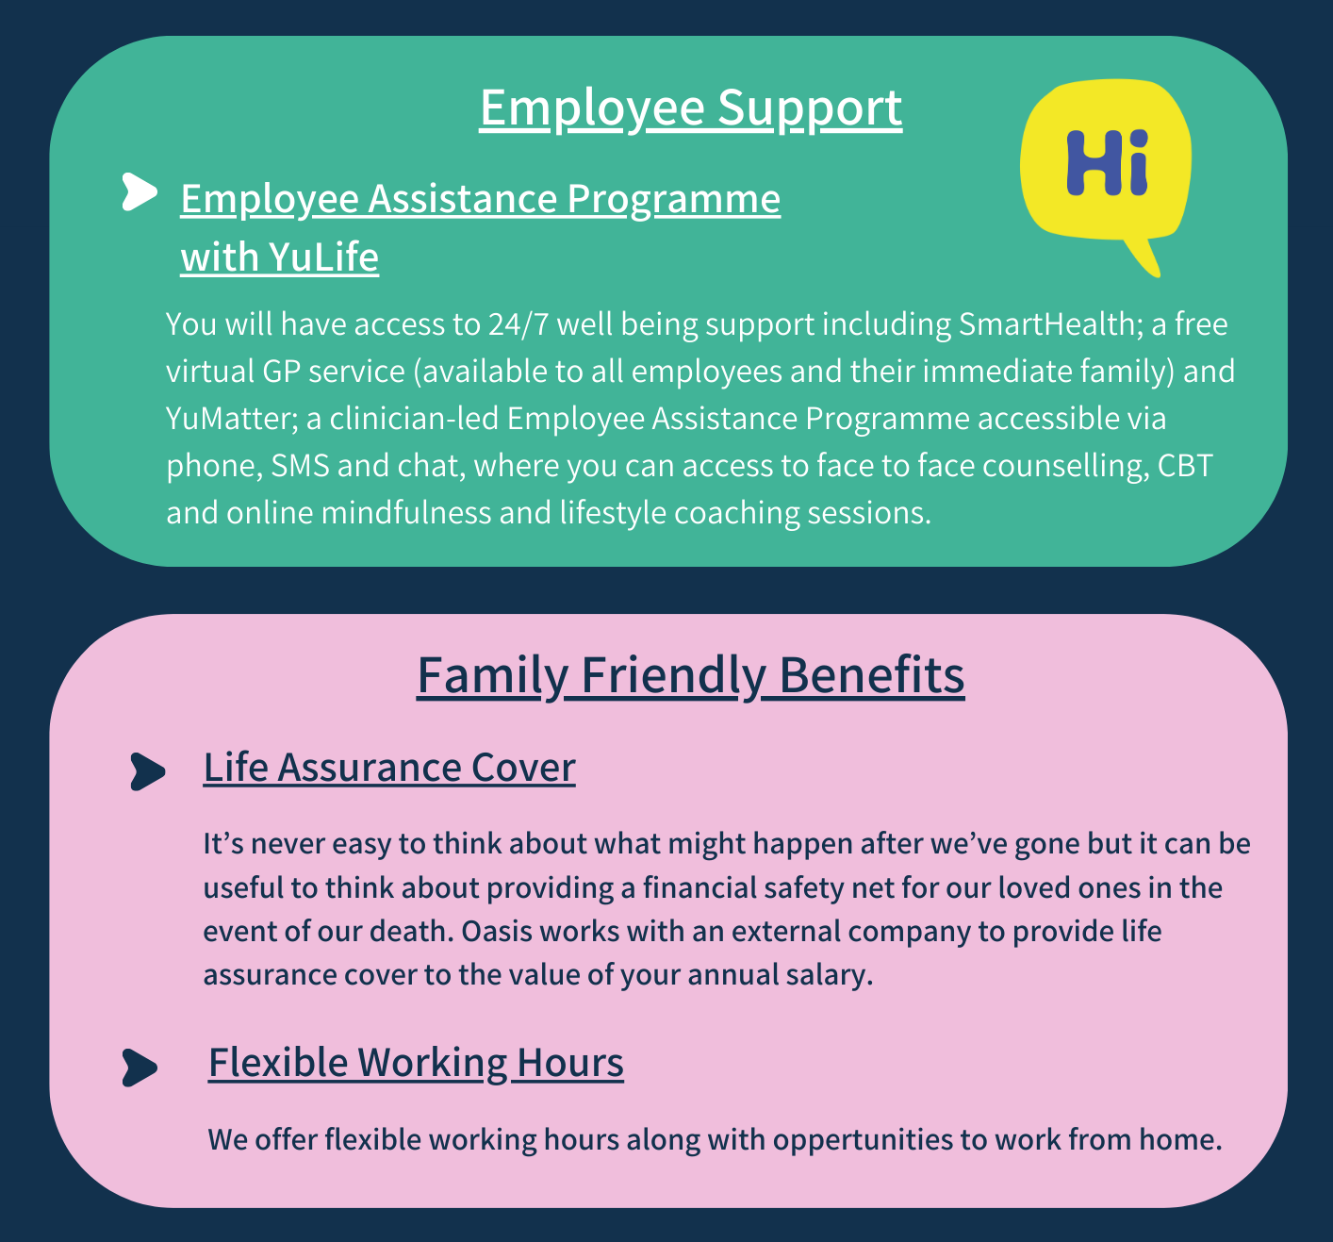

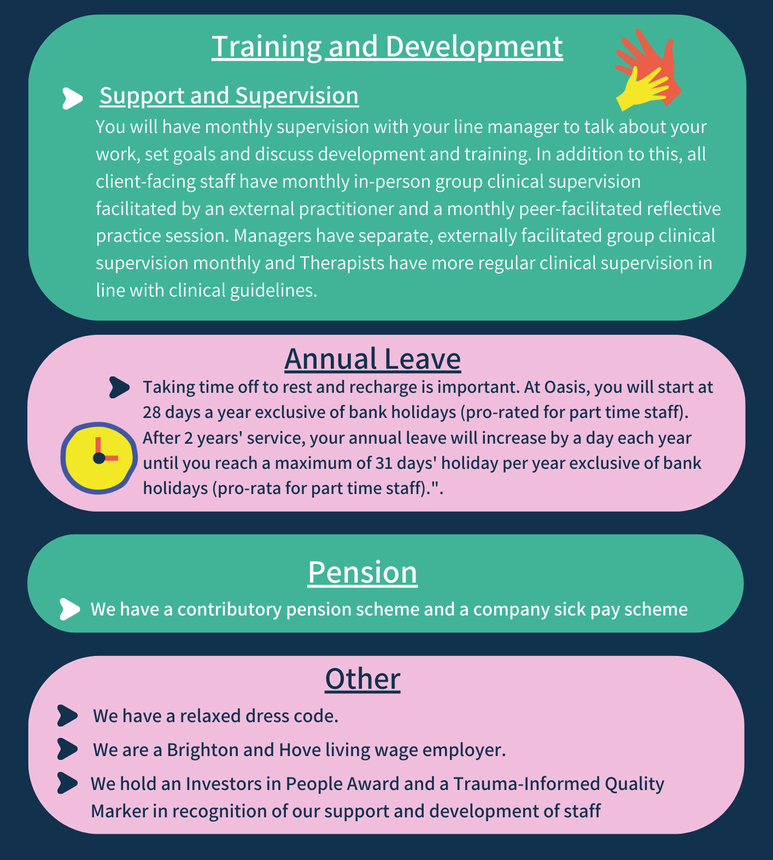

The Recruitment Process
At Oasis Project we are committed to providing the best possible recruitment service including working to remove barriers to equal opportunity at each stage of the recruitment process.
Our commitment to you is that:

- We will treat you in a polite, helpful and friendly manner at all times.
- Information that you provide will be treated as confidential and will be seen only by those involved in the recruitment process.

- We will ask you to complete an equal opportunities questionnaire – this information is only used for monitoring purposes.

- We will endeavor to make any reasonable adjustments to the interview process to enable you to participate

- We will communicate with you clearly, and as quickly as possible at each stage of the recruitment process

- We make it clear in the job advertisement when the interviews will be held.

- A decision will be made as soon as possible after interviews and you will be informed of the outcome

- Unsuccessful interviewees will be offered feedback.

Job Description

Finance Manager

Reports to: CEO
Team/Location: Central Support and Admin Team. Hybrid working between Oasis Project Brighton office and home (subject to organisational needs and policy).
Hours/Contract Type: 15 hours per week. PAYE or freelance considered; terms to be agreed in contract.
Salary: £40,000 FTE (£16,000 actual based on 15 hours per week) or freelance equivalent by agreement.

Introduction
Oasis Project was established in 1997 and gives hope to women, children and families affected by drugs & alcohol. We deliver a range of services as one of the only providers in the UK of gender-specific drug and alcohol treatment for women, alongside dedicated support for children and families. We are nationally recognised for our unique model of provision.

Oasis Project is a charity with a diverse income portfolio, drawing funding from statutory contracts as well as grants from charitable trusts and foundations. Around 80% of our expenditure supports a staff team of approximately 47 people (equivalent to about 32 full-time roles). You can find out more about us on our website and view our latest annual accounts online.

Job Purpose
As Oasis Project Finance Manager, you will oversee the charity’s financial operations, ensuring accuracy, compliance, and strong financial governance. Your responsibilities include overseeing bookkeeping and payroll, preparing monthly financial reporting, quarterly management accounts, and supporting strategic decision-making through budgeting and forecasting.

Main Duties and Responsibilities
- Oversee all aspects of financial management, including accounting, payroll, and statutory compliance.
- Prepare and present regular financial reports and management accounts to the CEO and Board.
- Lead on budgeting, forecasting, and financial planning in collaboration with senior management.
- Ensure robust financial controls and processes are maintained, in line with relevant policies and legislation.
- Line manage the Bookkeeper and support the development of the finance team.
- Liaise with auditors, external agencies, and stakeholders as required.
- Provide financial advice and support to the CEO, Treasurer, and Board.
- Ensure compliance with all relevant policies, including Data Protection, Safeguarding, and the Finance Control Policy.
- Maintain continual awareness of developments in legislation and policy relevant to the role.
- Undertake any other duties commensurate with the role as required by the organisation.
- Carry out any other reasonable instructions given by the CEO or Trustees.

Person Specification
PERSON SPECIFICATION | Essential or Desirable
Accounting Qualification Bookkeeping/Accounting Qualification (e.g. AAT or CIMA) – or part qualified, working towards qualification | Essential
Experience of Charity Accounting processes | Essential
Working knowledge of SAGE accounting software or similar system | Essential
Proven experience delivering training and skills to communicate with and influence people at all levels | Essential
Proven verbal and written communication skills with excellent IT skills | Essential
Ability to work effectively as part of a team as well as on own initiative | Essential

Completing your application
To apply for this role, please send your CV and a covering letter via the IRIS Platform. Please outline in your covering letter (in brief) the ways in which you have the skills to meet the requirements of the role. Please read the job description and person specification carefully and address your supporting statement to the stated criteria.

Recruitment checks
References
We require two references. They will not be contacted without your permission but we will
need to obtain two satisfactory references before you can take up any employment offered
to you. If you can provide an email address for your referees this is helpful.

Eligibility to work in the UK
We require you to provide appropriate ID documentation that proves your eligibility to work
in the UK or the appropriate share code to demonstrate settled status.

Occupational health check
You will be asked to complete an online medical questionnaire, via our occupational health
providers. Our occupational health experts will confirm to Oasis Project whether you are fit
(or not fit) to undertake the role, or if adjustments may be required, based on the
information that you have disclosed.

Ex-offenders / Disclosure and Barring Service (DBS) Checks
All applicants are required to disclose details of any unspent convictions in accordance
with the Rehabilitation of Offenders Act 1974. Any disclosure of an unspent conviction will
NOT automatically disqualify your application unless the nature of the offence renders you
unsuitable for the role. All such disclosures will be considered on an individual basis.
There is space on the application form for this information.

If your employment at Oasis will include working with children and vulnerable adults you
will be required to undertake a DBS check (with the costs for this being met by Oasis).

We wish you success with your application.

