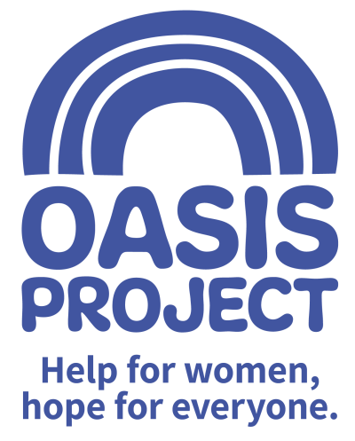
Job Description - Early Years Practitioner (Bank)

REPORTS TO: Early Years Manager
TEAM: Early Years / Young Oasis crèche
SALARY: £12.60 per hour (plus £2.03 per hour for holiday pay)
HOURS: Zero Hours Contract - varied hours
PURPOSE OF ROLE
To provide high quality childcare within our crèche, for babies and children of parents seeking support for their drug or alcohol use.
RESPONSIBILITIES
Service delivery
To proactively deliver high quality childcare for babies and children under 10 within the crèche, meeting the needs of the families and children using the service by:-
- Caring for the children’s physical needs including feeding, nappy change and toileting
- Caring for and promoting the physical, social, emotional, sensory and cognitive development of the children
- Promoting the development of children’s language and communication skills
- Observing and assessing the development and needs of children
- Contributing to the care and educational needs of children with special needs
- Working with the Early Years team to deliver structured programmes of play
- Contributing to the protection of children at risk by reporting concerns to the creche supervisor or manager and maintaining accurate records in line with Oasis protocols (training will be provided)
- Providing advice, support and guidance to parents to promote positive care and parenting skills, signposting parents to wider support services where required

Health and Safety
To assist the Early Years team in the delivery of a safe, healthy and secure crèche service by:-
- Following relevant procedure and policy, including in relation to nappy changing and toileting, admissions and drop offs, safeguarding and record keeping, data protection and confidentiality
- Keeping the creche environment clear and tidy, including clearing down after each session and setting up for the following session

General accountabilities
- Develop own levels of knowledge and practice, reflecting on and evaluating own values and effectiveness in the role
- Make use of supervision appropriately
- Demonstrate commitment to the vision and values of Oasis
- Demonstrate awareness and commitment to working in a way that is ‘trauma informed’ and to recognise this approach as part of Oasis’ overall commitment to providing gender responsive services for women.
- To undertake any other reasonable duties as requested by the line manager

PERSON SPECIFICATION | Essential or Desirable
Qualifications
NVQ Level 3 Diploma (Early Years) or willingness to work towards | Essential
First Aid / Pediatric First Aid | Desirable
SKILLS, EXPERIENCE AND EXPERTISE
1 years’ experience or more of working with children under 10 and their families | Essential
Experience of providing support and guidance to families to promote positive parenting and care | Essential
Able to carry out administrative duties including data entry | Essential
Knowledge of the issues facing substance misusers, in particular female substance misusers | Desirable
Knowledgeable about and committed to the principles of safeguarding | Essential
Able to maintain professional boundaries | Essential

The post is subject to the satisfactory completion of a Disclosure and Barring Service (DBS - formally CRB) check at an enhanced level.
This job description accurately reflects the present position; it may be reviewed and amended but only after a proper period of consultation.

