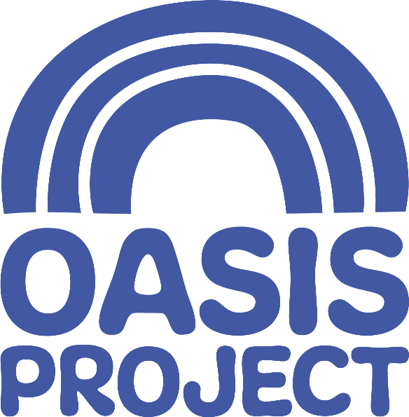

Equal Opportunities Monitoring Form
At Oasis Project, we imagine a world where people are free to be themselves and achieve their full potential. If you imagine this world too –then we’d love to work with you. In order for us to build and maintain an inclusive culture that represents all communities and identities, we ask anyone applying for a role to complete this form. It helps us track how well we’re doing at attracting, recruiting and retaining people from different backgrounds.

We know how important data security is, and we will only use this information for monitoring and reporting. Any information you share will be stored securely by our HR Adviser and Administration Manager and our reporting will ensure you are not be personally identifiable.
Which post are you applying for?
Where did you see the post advertsed?
(this helps us plan future job promotion)
What age are you? | ☐ 16-24  ☐ 25-29  ☐ 30-34  ☐ 35-39  ☐ 40-44  ☐ 45-49  ☐ 50-54  ☐ 55-59  ☐ 60-64  ☐ 65+  ☐ Prefer not to say

What gender are you? | ☐ Male  ☐ Female  ☐ Intersex  ☐ Non-binary  ☐ Prefer not to say  If you describe your gender with another term, please provide this here:
Are you trans or do you have a trans history? | ☐ Yes ☐ No ☐ Prefer not to say
What is your legal marital or civil relationship status? | ☐ Divorced  ☐ Formerly in a registered civil partnership which is now dissolved  ☐ In a registered civil partnership  ☐ Married  ☐ Never married and never registered a civil partnership  ☐ Separated, but still in a registered civil partnership  ☐ Separated, but still legally married  ☐ Surviving partner from a registered civil partnership  ☐ Widowed  ☐ Prefer not to say
Which of the following best describes your sexual orientation? (Please feel free to select more than one if more than one applies to you) | ☐ ACE (including asexual, greysexual, demisexual)  ☐ Bi (including pansexual)  ☐ Gay or lesbian  ☐ Heterosexual / straight  ☐ Prefer not to say  If you describe your sexual orientation with another term, please provide this here:
How would you describe your ethnic origin? | ☐ Arab  ☐ Asian or Asian British: Bangladeshi  ☐ Asian or Asian British: Chinese  ☐ Asian or Asian British: Indian  ☐ Asian or Asian British: Pakistani  ☐ Black or Black British: African  ☐ Black or Black British: Caribbean  ☐ Black African and White  ☐ Black Caribbean and White  ☐ White and Asian  ☐ Any other multiple ethnic background:  ☐ White: British (England / Scotland / Wales / Northern Ireland)  ☐ White: Irish  ☐ White: Roma  ☐ White: Gypsy or Traveller  ☐ White: Other  ☐ Prefer not to say  If you would prefer to use your own term, please provide this here:
Religion, faith and belief – What is your reigion?
☐ Agnostic  ☐ Atheist  ☐ Buddhist  ☐ Christian  ☐ Hindu  ☐ Humanist  ☐ Jain  ☐ Jewish  ☐ Muslim  ☐ Pagan  ☐ Sikh | ☐ I have no particular religion  ☐ Prefer not to say  ☐ If you would prefer to use your own term, please provide this here:
Disability
Do you consider yourself to be disabled? | ☐ Yes ☐ No ☐ Prefer not to say
Are your day-to-day activities limited because of a health problem or disability which has lasted, or is expected to last, at least 12 months? | ☐ Yes a little  ☐ Yes a lot  ☐ No (do not answer the next question)  ☐ Prefer not to say
(Please feel free to select more than one if more than one applies to you)
☐ Vision (e.g., due to blindness or partial sight)
☐ Hearing (e.g., due to deafness or partial hearing)
☐ Mobility, such as difficulty walking short distances, climbing stairs, lifting and carrying objects
☐ Learning or concentrating or remembering
☐ Mental health
☐ Stamina or breathing difficulty
☐ Social or behavioural (e.g., due to neuro diverse conditions)
☐ Other (welcome to provide details here):
☐ Prefer not to say

If you would prefer to use your own term, please provide this here:

Are there any adjustments, or accommodations that could help you feel safe and comfortable during the selection process and or during your day-to-day work? | If you feel comfortable, you are invited to share information here:
Carer:
Do you look after, or give any help or support to family members, friends, neighbours or others because of either long-term physical or mental ill-health / disability, or problems related to old age? | ☐ No  ☐ Yes, 1-19 hours a week  ☐ Yes, 20-49 hours a week  ☐ Yes, 50 or more hours a week  ☐ Prefer not to say
If yes, who do you care for? | ☐ Primary carer of a child/children (under 18)  ☐ Primary carer of disabled child/children  ☐ Primary carer of disabled adult (18 and over)  ☐ Primary carer of older person  ☐ Secondary carer (another person carries out the main caring role)  ☐ Prefer not to say
Armed forces service:
Are you currently serving in the UK Armed Forces (this includes reservists or part-time service, eg: Territorial Army)? | ☐ Yes ☐ No
Have you ever served in the UK Armed Forces? | ☐ Yes ☐ No
Are you a member of a current or former serviceman or woman’s immediate family/household? | ☐ Yes ☐ No
Socio-economic background:
How would you describe your socio-economic background? (Please answer this based on your circumstances as a child, e.g., family income, housing, and employment.) | ☐ Middle class  ☐ Upper class  ☐ Working Class  ☐ Prefer not to say  If you would prefer to use your own term, please provide this here:

Thank you for taking the time to complete this form.

This is sensitive personal data and will be treated with the utmost confidentiality in line with GDPR and the DPA 2018. The data will only be used for general statistical and monitoring purposes. In doing this, we are able to assess if we are effectively reaching out to diverse populations.

