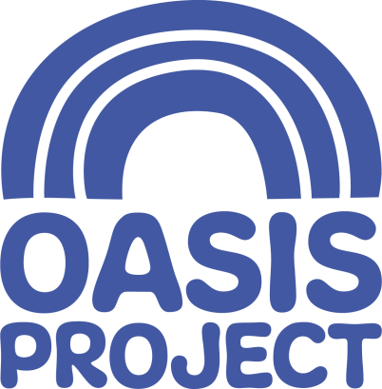
BECOME A CORPORATE SPONSOR FOR OASIS PROJECT
A Proposal from Oasis Project

Introduction
Established by women who felt that substance misuse treatment services did not meet their needs, Oasis Project has been making a difference to women and families in the region for the last 21 years. The project has grown to become one of the most recognised substance misuse services in the South East whilst remaining true to the original vision of addressing inequality in access to treatment.

What We Do
Oasis Project is a substance misuse service for women and families. With its HQ in Brighton city centre and additional bases in Eastbourne and Hastings, we provide a range of recovery-focused treatment services to support and empower women who have difficulties with drink or drugs to make positive changes in their lives. Our portfolio includes services for women working in the sex industry, women offenders, women with multiple and complex needs and young women with alcohol problems. We also provide services for children and young people affected by substance misuse in the family. Our aim is to create opportunity, instil hope, nurture courage and restore personal belief in what is possible and achievable for women, children and families.

Why Women?
Our model of service provision is unique in the UK although there are acknowledged, compelling reasons for taking a gender-specific approach. Women remain outnumbered 3-1 in treatment services and there are well documented links between sexual and domestic violence and substance misuse. Women have a better chance of overcoming addiction and maintaining recovery within an all women environment where they feel more able to openly discuss issues that affect them. The women we work with tell us that with Oasis they feel safer and better understood.

Who comes to Oasis?
It can suit some people to think that drug and alcohol problems affect a small amount of people or that the people affected are to blame for their own problems. The truth is that problems with drugs and alcohol are widespread and affect all sorts of people regardless of their background. They are most often the manifestation of deeper issues. We directly support over 750 women and 200 children each year.

Children and Young People
The service was developed with a crèche for babies and children, enabling women with child-care responsibilities to access treatment. Since 2000 we have been providing services, including 1-1 therapies and holiday arts activities, for children and young people who have been affected by problematic drug or alcohol use in their family. Safeguarding children and promoting their wellbeing is at the core of our work in breaking intergenerational cycles of deprivation in our city.

To further our impact within the third sector and help us to raise our profile in the Brighton community we are looking for businesses to become our official corporate sponsors going forward.
Why we should be your Nominated Charity
Our annual running costs are currently in excess of £1million and we rely heavily on public fundraising and donations. Your support will contribute greatly towards our fundraising efforts and enable us to continue planning for the future of the charity. As Oasis is a relatively small charity, your involvement and support will also help give us the platform we need to continue raising our profile. You will be helping to create opportunities for us to recruit and retain the support of the local community.
Examples of our expenditure:
£1,000 will pay for a 16-week course of 1:1 therapy for five children and young people affected by problematic drug or alcohol use in the family
£5,000 will pay for 12 months of clinical supervision for every staff member in the Adult Services team to ensure the quality and effectiveness of our service delivery and support staff in their professional development
£10,000 will pay for the employment of a part-time crèche worker qualified in early years development to work with, play with and educate some of the 75+ infants and children who come to Oasis’ therapeutic crèche

We welcome you to visit us at Oasis Project to gain a fuller insight into who we are, how we work and who we help. Please arrange this with us at your convenience.

What you will receive
- Your logo on all Oasis marketing material
- Branding opportunities at all events run by Oasis
- Your logo and a hyperlink to your website on the ‘Supporters’ page of the Oasis website
- Opportunities to speak at Oasis events
- Press and media coverage, for example press releases and local radio interviews
- Social media coverage reaching 3000 followers on Twitter
- Contribution to your company’s annual CSR programme
- Opportunities to become a member of our Board of Trustees
- Opportunities for your employees and colleagues to volunteer with us
- Partnership with an amazing cause and a growing name in the local charity sector
Other ways in which you can help
- Staff volunteering
- Website and social media support
- Fundraising initiatives / events
- Word of mouth

Please call our CEO, Laura Ward, to discuss your support:
01273 696970 (opt. 5)
07815 883331
Laura.ward@brightonoasisproject.co.uk

Thank you for your interest in Brighton Oasis Project

