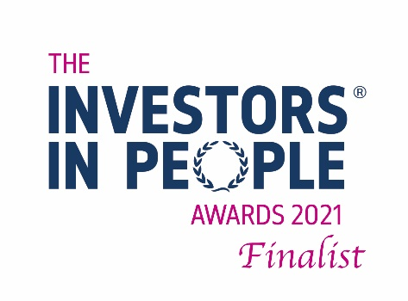
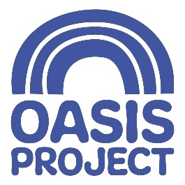

OASIS PROJECT HAS BEEN SHORTLISTED IN THE INVESTORS IN PEOPLE AWARDS 2021

Oasis Project has made the final shortlist for The Third Sector Award in The Investors in People Awards 2021. In a record-breaking year for entries, with nearly three hundred organisations involved, this is an outstanding achievement and one that everyone at Oasis is proud of.

The Investors in People Awards celebrate the very best organisations and individuals from around the world across various organisational, people, wellbeing and leadership categories. Each year hundreds of organisations from the UK and abroad battle it out to take home one of the sought after trophies to show their award-winning commitment to investing in their people.

Laura Ward, the CEO at Oasis said “It is a privilege to be shortlisted for this award; a clear indication of the dedication and hard work the team has invested in the organisation.”

Paul Devoy, CEO of Investors in People, commented, “Now in our 8th year, it always makes me feel immensely proud to see so many fantastic organisations staking their claim to be the best. And every year, the entries do get more and more competitive and the judging even tighter. Reaching the final shortlist is a testament to the amazing commitment these organisations are making to make work better for their people, and they truly deserve this recognition.”

The Winners will be announced at an online ceremony on the 23rd November 2021.
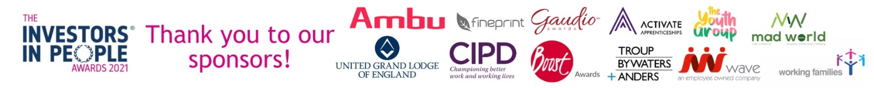
For the full shortlist and more information about Investors in People please visit www.investorsinpeopleawards.com.

The Investors in People Awards 2021 are proudly sponsored by Activate Apprenticeships, Ambu, Boost Awards, CIPD, Fineprint, Gaudio Awards, Make a Difference Summits, The Youth Group, Troup Bywaters + Anders, United Grand Lodge of England, WAVE Refrigeration and Working Families.

