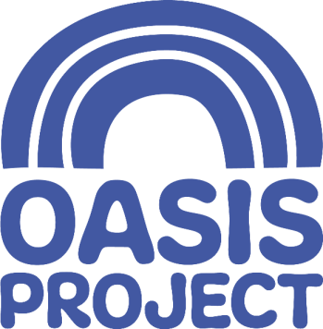
Open Access Referral Form

- Support for women who would like advice, help or guidance concerning their drug or alcohol use.
- Please return completed forms to referrals@oasisproject.org.uk

CLIENT NAME
Name of person completing this form, including organisation (if applicable) and contact details
If you are making a self-referral, leave this section blank
Date referral made
Date of Birth
Ethnicity
Address
Postcode must be BN1, BN2, BN3 or BN41
Telephone Number
Email Address
Can we contact you by: | Please indicate
Phone | Yes/No
Text message | Yes/No
Voicemail | Yes/No
Email | Yes/No
Letter | Yes/No
Current problems with drugs / alcohol. Which substance(s)? Quantity and frequency?

Are you currently in treatment?
If so, what’s the name of your care coordinator?
How did you hear about Oasis?
Is this the first time you have contacted us?
Do you have any disabilities or access requirements? | Yes / no
Do you have any children? If yes, what are their ages?
If yes, do they need a crèche space?

Is there anything else you’d like to tell us?
For office use only: IF ALCOHOL AND PARENT BOOK IN WITH FAMILY PRACTITIONER
APPOINTMENT DATE/TIME
Add to spread sheet with your initials and client contact number.
Risks we should be aware of, including concerns from other services, risks to self and/or others.
Any other relevant information

- Please return completed forms to referrals@oasisproject.org.uk

