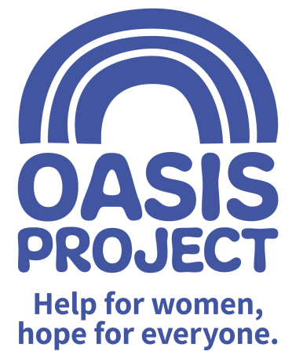

Role profile:
Role title: Female* Substance Misuse Recovery Worker | Reports to: Adult Services Manager
Team: Adult Services | Salary: £22,500 per year FTE
Hours: Part Time and Full Time considered

Contract type: Permanent

Purpose of the role:
Oasis Project is a gender-specific drug and alcohol treatment service which provides care coordination and group support to adult women wishing to address their substance use. Your role as a Substance Misuse Recovery Worker will include conducting assessments, providing care coordination to a caseload of women on an individual basis (face to face and over the phone) and facilitation of groups. You will agree and formulate individual care plans with women you support to ensure the promotion of choice and independence.

Responsibilities:
Client Service Delivery
- Conduct assessments of clients newly referred to the service
- Manage a caseload of female service users
- Deliver 1-1 care coordination support (face to face and over the phone) using a keywork approach to support individuals in reducing substance misuse and preventing relapse
- Facilitate engaging, inclusive groups (face to face and online) for women
- Support women with additional complexities such as past trauma, dual diagnosis and/or domestic violence
- Be creative and innovative in delivery of a high quality, person centred recovery service provision
- Support and facilitate clients’ engagement with other relevant services e.g. housing, mental health, recovery and wellbeing, signposting or making onwards referrals as needed
- Recognise indicators of risk, safeguarding and harm
- Promote a successful recovery and further community engagement
- Attend/lead or share reports for multi-agency professionals’ meetings where appropriate
- Maintain timely and accurate client case notes and records using our client database management system

Adult and Child Safeguarding
- Be committed to the safeguarding of children and adults affected by substance misuse
- Be familiar with Oasis’ safeguarding practice and procedures, taking appropriate action as necessary
- Maintain a good level of professional curiosity at all times
- Keep up to date with training
Service commitment and accountability
- Contribute to service planning, delivery and evaluation
- Develop professional links with other agencies
- Engage in regular supervision
- Adhere to policy, procedures and guidance
- Comprehend and employ the core truths of Oasis project as a gender specific service with a trauma informed approach

Values and Ethos
- Demonstrate commitment to the vision and values of Oasis and understand how your own behaviour and actions impact this
- Contribute to maintaining a culture of shared ownership and responsibility that supports Oasis in achieving its overall mission.
- Understand and commit to equality, diversity and inclusion best practice with a particular focus on hard to reach and marginalised women service users.
- Observe professional boundaries in relationships with service users, peers and other relevant professionals
- Participate in the continuous improvement of Oasis’ services

Compliance
- Ensure that Oasis and its services are represented in a professional manner at all times
- Meet agreed performance targets and outcomes
- Use management information and data as appropriate
- Comply at all times with health and safety regulations
- Ensure risk assessments are completed as appropriate
- Take personal responsibility for own safety
- Comply with all relevant policy and procedure, standards and codes of conduct
- Meet all regulatory requirements
- Comply with Oasis’ policy and procedure particularly confidentiality and data protection guidance
- Use IT and data management systems to keep records up to date in line with agreed processes
- Undertake any other reasonable duties as requested by the line manager

Communication and Relationships
- Provide information and raising awareness about substances, their use and effects on an individual basis and via facilitating collaborative group learning;
- Ensure a collaborative approach is used, ensuring effective communication within a multi-disciplinary team
- Contribute to the prevention and management of abusive, aggressive and challenging behaviour
- Work as an effective member of the team
Problem Solving and analysis
- Develop and disseminate information and advice about health and social well being
- Apply recognised theoretical models to enable individuals and groups to identify and explore concerns relating to their substance misuse
- Carry out testing and comprehensive assessment to identify alcohol and other substances
- Contribute proactively to the principle of continuous improvement by making positive suggestions and constructive feedback and helping with the implementation of agreed new ways of working

Continuous Development
- Reflect on and develop your own practice
- Monitor your own performance to ensure it meets expectations and agreed performance targets
- Make use of supervision opportunities, ensuring there is two-way dialogue
- Participate in training and other development opportunities
- Contribute to the development and knowledge of others by sharing your experience and skills

PERSON SPECIFICATION | Essential or Desirable
Social work qualification, Nursing RMN RGN or NVQ level 3 in health and social care | Essential
Proven track record of delivering agreed service targets in a flexible, creative way as well as being able to deliver structured interventions in the substance misuse sector | Essential
Knowledge of the key issues facing substance misusers, in particular female substance misusers and a commitment to helping women access relevant support | Essential
Proven verbal and written communication skills with excellent IT skills and database inputting | Essential
Experience of providing community based support practices and of working in partnership with other agencies | Essential
Ability to work effectively as part of a team as well as on own initiative | Essential
Resilient attitude and ability to work in a way that is reflective, adaptable and non-judgmental and adheres to professional boundaries at all times | Essential
Experience of managing a caseload of clients in line with agreed processes | Essential
Knowledge and experience of safeguarding procedures and processes, confidentiality procedures and data protection guidelines | Essential
Proven track record in managing incidents of aggression and challenging behaviour | Desirable

*This role is only open to female applicants as being female is deemed to be a genuine occupational requirement under Schedule 9, Paragraph 1 of the Equality Act 2010.

The post is subject to the satisfactory completion of a Disclosure and Barring Service (DBS - formally CRB) check at an enhanced level. This job description accurately reflects the present position; it may be reviewed and amended but only after a proper period of consultation.

