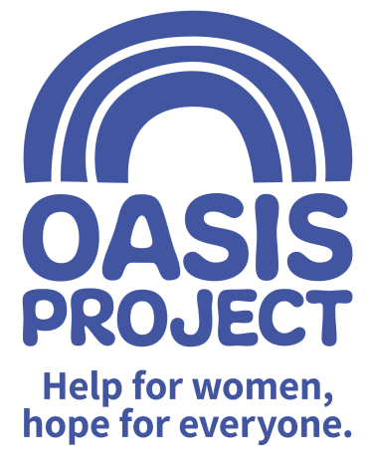

Role profile:
Role title: Female* Recovery Worker | Reports to: OWRS Manager
Team: Oasis Women’s Recovery Service (OWRS) – East Sussex | Salary: £22,500 per year FTE
Hours: 22.5 hours/3 days a week
Contract type: Fixed term contract until June 2022 with the possibility of extension.
Purpose of the role:
Since 2016 Oasis Women’s Recovery Service (OWRS) has been delivering a range of recovery-focused activities and services to women in across East Sussex who have problems with drugs/alcohol. This role would be home-based working for now, with likely office-based and outreach work in the future.

Responsibilities:
Client Service Delivery
- Manage a caseload of service users
- Be creative and innovative in delivery of a high quality, person centred recovery service provision
- Promote the rights and responsibilities of women, mapping barriers to support
- Recognise indicators of risk, safeguarding and harm
- Support individuals in reducing substance misuse and preventing relapse
- Support women with additional complexities such as past trauma, dual diagnosis and/or domestic violence
- Promote a successful recovery and further community engagement
- Support clients to access positive opportunities in work or training
- Make referrals or signpost clients to further support
- Attend/lead or share reports for partnership meetings where appropriate

Adult and Child Safeguarding
- Be committed to the safeguarding of children and adults affected by substance misuse
- Be familiar with best safeguarding practice and procedures, making awareness of documentation pathways at Oasis a priority and taking appropriate action as necessary
- Maintain a good level of professional curiosity at all times
- Keep up to date with training
Service commitment and accountability
- Contribute to service planning, delivery and evaluation
- Develop professional links with other agencies, utilising a corporate approach
- Engage in regular supervision
- Adhere to policy, procedures and guidance
- Comprehend and employ the core truths of Oasis project as a gender specific service with a trauma informed approach

Values and Ethos
- Demonstrate commitment to the vision and values of Oasis and understand how your own behaviour and actions impact this
- Contribute to maintaining a culture of shared ownership and responsibility that supports Oasis in achieving its overall mission.
- Understand and commit to equality, diversity and inclusion best practice with a particular focus on hard to reach and marginalised women service users.
- Observe professional boundaries in relationships with service users, peers and other relevant professionals
- Participate in the continuous improvement of Oasis’ services

Compliance
- Ensure that Oasis and its services are represented in a professional manner at all times
- Meet agreed performance targets and outcomes
- Use management information and data as appropriate
- Comply at all times with health and safety regulations
- Ensure risk assessments are completed as appropriate
- Take personal responsibility for own safety
- Comply with all relevant policy and procedure, standards and codes of conduct
- Meet all regulatory requirements
- Comply with Oasis’ policy and procedure particularly confidentiality and data protection guidance
- Use IT and data management systems to keep records up to date in line with agreed processes
- Undertake any other reasonable duties as requested by the line manager

Communication and Relationships
- Provide information and raising awareness about substances, their use and effects on an individual basis and via facilitating collaborative group learning;
- Ensure a collaborative approach is used, ensuring effective communication within a multi-disciplinary team
- Contribute to the prevention and management of abusive, aggressive and challenging behaviour
- Work as an effective member of the team
Problem Solving and analysis
- Develop and disseminate information and advice about health and social well being
- Apply recognised theoretical models to enable individuals and groups to identify and explore concerns relating to their substance misuse
- Complete analysis at client referral, continually asses the client via the secondary stages of assessment, unique recovery planning and following up treatment outcome profiling
- Contribute proactively to the principle of continuous improvement by making positive suggestions and constructive feedback and helping with the implementation of agreed new ways of working

Continuous Development
- Reflect on and develop your practice
- Monitor own performance to ensure it meets expectations and agreed performance targets
- Make use of supervision opportunities, ensuring there is two-way dialogue
- Participate in training and other development opportunities
- Contribute to the development and knowledge of others by sharing your experience and skills

PERSON SPECIFICATION | Essential or Desirable
Experience of working within the substance misuse sector; and a proven track record of delivering structured interventions in line with agreed service targets and objectives in a flexible, creative way; | Essential
Knowledge of the key issues women substance misusers face and a commitment to helping them access relevant support | Essential
Experience of working with women who have been victims of violence including sexual violence and exploitation | Essential
Proven verbal and written communication skills with excellent IT skills and experience of using data management systems | Essential
Ability to work effectively as part of a team as well as on own initiative | Essential
Resilient, empathetic attitude and work in a way that is reflective, adaptable and non-judgemental and adhere to professional boundaries at all times | Essential
Knowledge and experience of safeguarding procedures and responsibilities; confidentiality procedures and data protection guidelines | Essential
Experience running and facilitating groups and supervising volunteers | Essential
Be willing and able to travel across the county, including to remote areas | Essential
NVQ3 in health and social care, or equivalent, or be willing to work towards this | Desirable
Experience of service user involvement and co-production | Desirable
Experience of providing community based support practices and of working in partnership with other agencies | Desirable

This role is only open to female applicants as being female is deemed to be a genuine occupational requirement under Schedule 9, Paragraph 1 of the Equality Act 2010.

The post is subject to the satisfactory completion of a Disclosure and Barring Service (DBS - formerly CRB) check at an enhanced level. This job description accurately reflects the present position; it may be reviewed and amended but only after a proper period of consultation.

