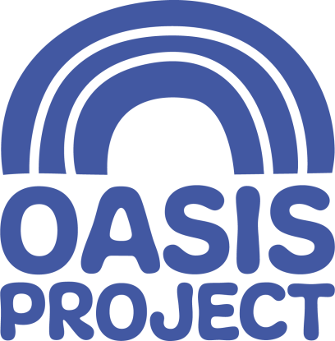

OWRS Project Worker (Female*)
Part-Time 22.5 hours per week over three days
£22,500 per year (FTE)

This role is a fixed term contract until end June 2022

Who we are:
For over 23 years Oasis Project (Oasis) has been delivering services for women with drug and alcohol problems and children affected by drug use in the family. We are an innovative, creative and forward-thinking organisation, which aims to empower women affected by substance misuse. We give help and hope to women and children affected by drug and alcohol problems.

About this role
Since 2016 Oasis Women’s Recovery Service (OWRS) has been delivering a range of recovery-focused activities and services to women who have problems with drugs/alcohol. This is an exciting opportunity to be part of a small team that makes a big difference to the lives of women in East Sussex.

In line with Government guidance, we anticipate the post-holder would be home-based initially but with a view to being based in the office and delivering outreach in the future. The postholder will support women across the county of East Sussex delivering 1-1 support as well as facilitating groups and other recovery focused activities.
You will have:
- Experience of working with people with substance misuse issues and multiple, complex needs;
- A proven track record of delivering structured interventions for clients with complex needs including delivering individual and group work;
- Knowledge of the key issues clients with multiple and complex needs face and a commitment to helping them access relevant support;
- Proven verbal and written communication skills with excellent IT skills and experience of using database management systems;
- Experience of providing community based support practices and of working in partnership with other agencies;
- An ability to work effectively as part of a team as well as on own initiative;
- A resilient, empathetic attitude and work in a way that is reflective, adaptable and non-judgmental and adhere to professional boundaries at all times;
- Knowledge and experience of safeguarding procedures and responsibilities; confidentiality procedures and data protection guidelines.
- Experience running and facilitating groups.

What we offer:
- Generous holiday entitlement
- We are a living wage employer
- We are committed to staff training and development
- Wellbeing and flexible working

Oasis is committed to inclusion and diversity and welcomes applications from people with relevant life as well as professional experience, and those with disabilities who are currently under-represented in the organisation. People from Black and Minority Ethnic communities are underrepresented in our organisation and we particularly welcome applications from this group.

For a full job description, person specification and application pack, please visit our website www.oasisproject.org.uk; or you can email recruitment@oasisproject.org.uk. If you would like to chat to someone about the role, please contact Rachel Britt on 07718 126515.

Closing date for applications is 9 am Friday 26 February 2021.

Interviews will take place the week commencing 8 March 2021.

Application is by application form only, please do not send a CV.

* This post is only open to female applicants as being female is deemed to be a genuine occupational requirement under Schedule 9, Paragraph 1 of the Equality Act 2010

Charity no: 1065503 Company no: 3447762

