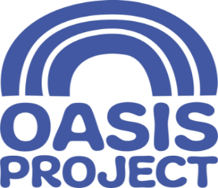

CLEANER (Female*)
1 x Part Time (15 hours per week) post – variable hours to be agreed
£9.30 per hour (Brighton and Hove Living Wage)
The post is based in Brighton

We are a charitable organisation and we offer a great place for you to work. We are a values-based organisation who put the people we support first. We are an innovative and forward-thinking organisation with the aim of empowering women, children and young people affected by substance misuse, offering help and hope.

We are seeking to recruit an in-house cleaner for our 2 locations in Brighton (very close geographically). You will need to be reliable, pro-active and take pride in the job you do. There may be some out of office hours required.

Oasis is keen to recruit people in every role with the right values and behaviours who can help us ensure our workplace values are at the heart of everything we do. Our values include:
- Being CARING – acting with respect
- Being ACCOUNTABLE – delivering a quality service
- Working COLLABORATIVELY – Valuing team work, and effective communication
- Valuing LEARNING

Do you share these values? Does this sound like the right opportunity for you? If so, we want you! Please apply by completing an application form (and equality monitoring form). For more information please call Charis or Lisette on 01273 696970 (x 402)

- Closing date for applications is 9am on Wednesday 4 March 2020
- Interviews will take place on a date to be confirmed in March

For a full job description and person specification please visit our website www.oasisproject.org.uk
If you have not heard from Oasis by 13 March you will not have been successful on this occasion; but we thank you for your interest. Application is by application form only, please do not send a CV. Please do complete the equality and diversity monitoring form and send with your application. *This role is only open to female applicants as being female is deemed to be a genuine occupational requirement under Schedule 9, Paragraph 1 of the Equality Act 2010.
Charity no: 1065503 Company no: 3447762
Oasis is committed to equal opportunities and welcomes applications from people with relevant life as well as professional experience, and those with disabilities or from Black and Minority Ethnic Communities who are currently under-represented in the organisation.

