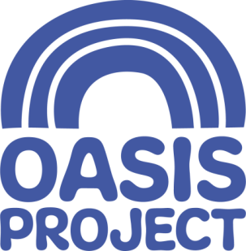

We are a values-based organisation who put the people we support first. We are innovative and forward-thinking with the aim of empowering women, children and young people affected by substance misuse; offering help and hope.

Internship – 30 week professional placement to commence September 2020
(up to 40 weeks available)
Expenses paid

We are currently looking for an enthusiastic and motivated intern for a 30-40 week placement. The internship will provide extensive experience in a number of areas:

- Being part of a multi-skilled team that includes substance misuse workers, early years workers, therapists and counsellors
- Understanding the importance of confidentiality, data protection and safeguarding practices
- Shadowing staff in their 1-1 work and group work sessions with clients
- Developing administrative and organisational skills with a focus on quality assurance

The key skills we are looking for include:

- Psychology undergraduate preferred (but open to other undergraduates)
- A confident and competent use of Microsoft office suite including Word, Excel and Outlook
- Experience of using the internet for research purposes
- Ability to work calmly in busy and possibly challenging situations
- Being well organised and able to use the time available effectively
- Ability to be able to use own initiative and be self motivated
- Being confident at talking to a wide range of people and remaining professional
- Wanting to be part of a team

In additional the internship will have some focus on building on and improving the quality assurance frameworks within the organisation ensuring that all policies and procedures are consistent and can be cross-checked; supporting the team with their monitoring and reporting; and ensuring that there is comprehensive governance and reporting mechanisms.

For a full job description and person specification please go to our website www.oasisproject.org.uk and access the documents. If you would like to chat to someone about this intern opportunity please contact Lisette Whittaker, Business Manager on 01273 696970

Closing date for applications is 10am on 30 March 2020 / Interviews on a date to be agreed after this date
Oasis is committed to equal opportunities and welcomes applications from people with relevant life as well as professional experience, and those with disabilities who are currently under-represented in the organisation. People from Black and Minority Ethnic communities are underrepresented in our organisation and we particularly welcome applications from this group.

Charity no: 1065503 Company no: 3447762

