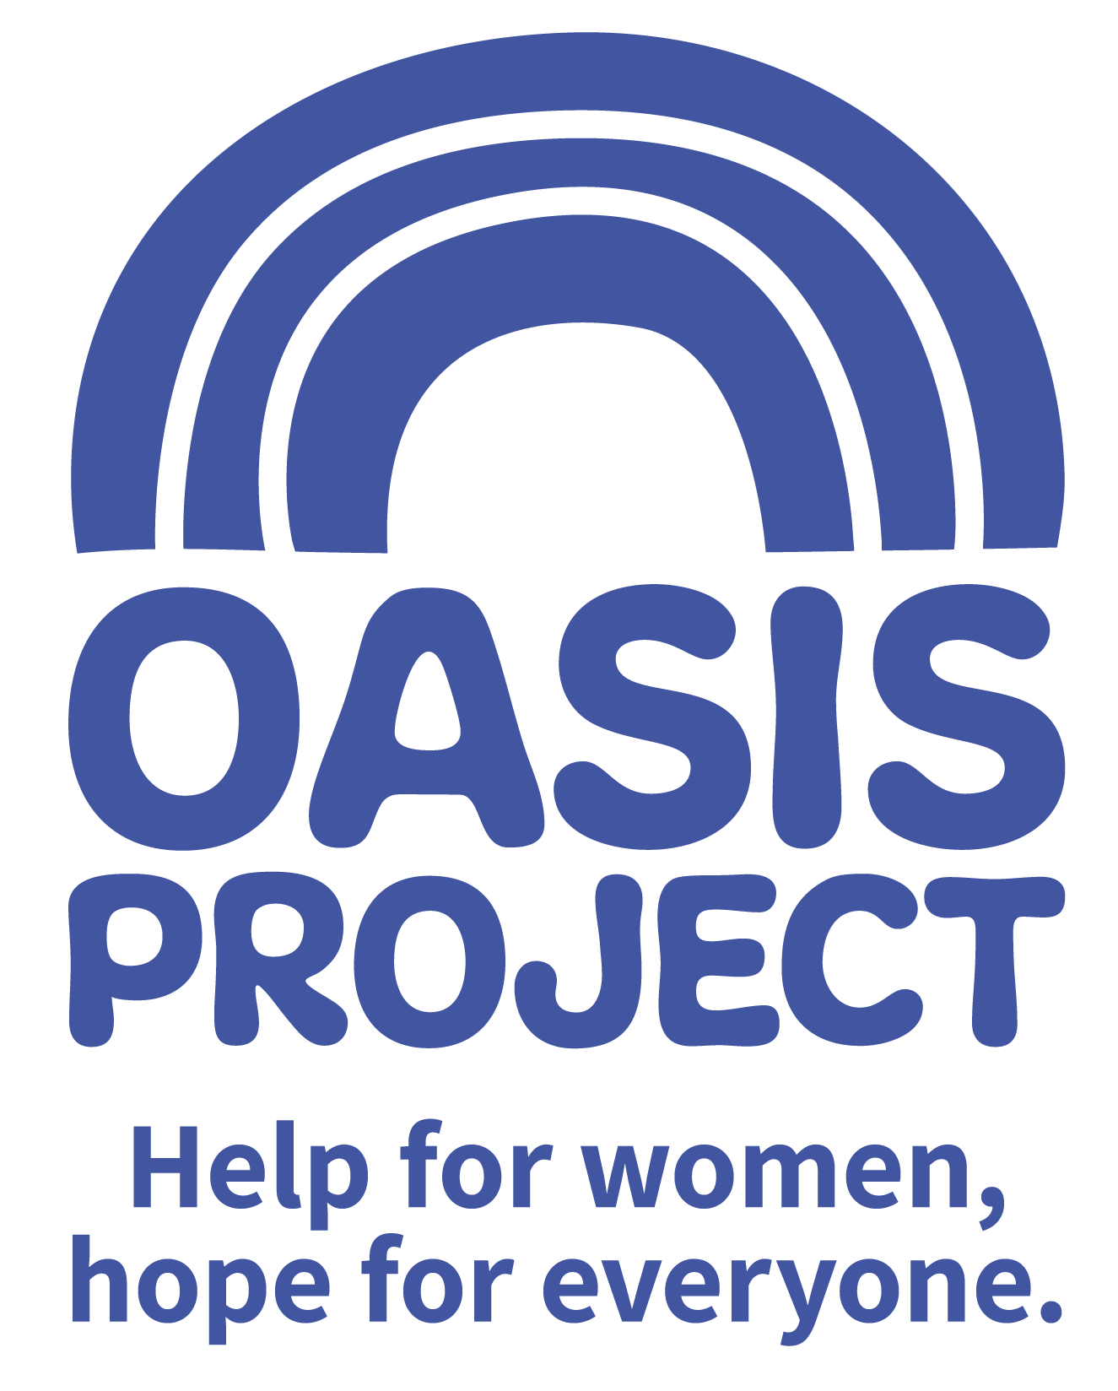

Community Fundraiser

£19,000 per year FTE
22.5 hours per week over 3 days with occasional evening and weekend work
The role is a permanent contract

Based in Brighton but travel to other Sussex locations occasionally required

Thank you for your interest in Oasis Project and the role of Community Fundraiser

This is your application pack. It will tell you about our activities and how you can apply for this role. After reading the pack we hope you will still be interested in applying and ask that you complete the application form and return it to us:

- By email to recruitment@oasisproject.org.uk
- Send by post to Globe House, 3 Morley Street, Brighton, BN2 9RA

Closing date is 9am on Monday 6 January 2020

Interviews will be held on Friday 10 January 2020. The interview process will involve a series of competency based interview questions and a short presentation task.

We hope the successful candidate will be able to start as soon as possible, once recruitment checks are completed.

You will find the following enclosed within this pack:

- Introduction to Oasis Project

- Working at Oasis Project

- The recruitment process

  - Selection
  - Job description and person specification
  - Completing your application
  - Submitting your completed application
  - References, occupational health checks, UK work eligibility checks and DBS disclosure

Introduction to Oasis Project


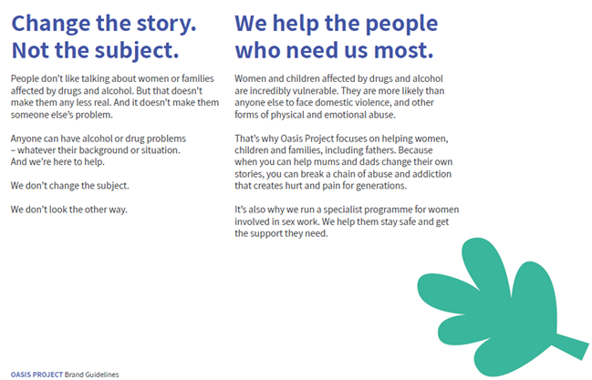

Working at Oasis Project:

Our vision and values underpin the services provided and how they are delivered to clients, as well as to how its employees and volunteers are treated.

We are a small to medium sized organisation. We have approximately 50 employees working a range of flexible hours. This means we are small enough to encourage collaborative working, learning from each other, make decisions quickly and enjoy working in a dynamic and exciting environment. We welcome the views of everyone within the team regardless of length of service and will value your views, perspectives and opinion.

Whilst we enjoy working as a team, the organisation has some key areas of work.
- Young Oasis team (made up of the crèche, therapy services for young people, and young women’s alcohol services)
- Adult services team
- Sex workers outreach project
- Fulfilling Lives Projects in East Sussex
- Smaller short term projects
- Administrative and fundraising functions.

As a paid employee at Oasis, you will be expected to:
- Meet the skills and requirements as outlined in the job description and person specification for this role;

- Make sure that you can commit to the specific hours and days of work that the role requires;

- Make sure that you are able to travel to and from the Brighton Oasis project offices based at 11 Richmond Place, Brighton and at Globe House, 3 Morley Street, Brighton (or other work venue as required).

- Discuss and agree any support needed with your line manager or Human Resources

- Engage with a culture of continuous professional development

- Observe the relevant requirements of all Oasis Project policies.

In return you can expect

Challenge and experience

This role offers a fantastic step to develop your career in fundraising and make a real difference to the organization. You will be able to use your creativity and energy to bring your fundraising ideas to fruition.

Training and support

Oasis Project provides you with regular one to one sessions with your line manager and an annual appraisal to review progress and identify areas for development. We also strongly encourage continuous professional development and encourage learning from a range of different opportunities.

We like to develop talent and provide opportunities such as secondments to ensure our employees continue to grow and learn, and can remain motivated and passionate about their work.

Benefits

In return for your time and skills at work you will receive
- a fair salary, comparable with similar roles in the area.
- 28 days (210 hours) annual leave plus bank/public holidays pro rata (full time) or pro rata equivalent
- Training and learning opportunities
- Study leave for approved courses/training
- An employer contribution of 3% into our stakeholder pension scheme via Bluesky (on condition that you remain enrolled in the pension scheme and contribute a minimum of 5% of your salary).
- Free tea and coffee
- Occupational health – eye tests reimbursed; other health support provided as necessary.

Career and other benefits

Oasis Project aims to be an employer of choice. We are a professional, well-respected organisation and showing that you have been employed here is great experience to put on your CV. We hold the Investors in People external accreditation.
Insurance

All employees are covered by Oasis Project’s insurance policy. To ensure that you have adequate cover it is important that you follow the guidelines of your role at all times.

THE RECRUITMENT PROCESS
At Oasis Project we are committed to providing the best possible recruitment service including working to remove barriers to equal opportunity at each stage of the recruitment process. Our commitment to you is that:

- We will treat you in a polite, helpful and friendly manner at all times.
- Information that you provide will be treated as confidential and will be seen only by those involved in the recruitment process.

- We will remove all personal information from your application to ensure that the short listing panel are not aware of whose application they are assessing.

- We will ask you to complete an equal opportunities questionnaire – this information is only used for monitoring purposes.

- We will endeavour to make any reasonable adjustments to the selection process (application form, interview or training) to enable individuals to participate equally

- If you are selected to progress to the next stage you will be advised as soon as possible.

- We will make it clear in the job advertisement when the interviews will be held.

- We will not contact your referees unless you give your permission. We will however need to obtain 2 satisfactory references as a condition of any employment offer.

- A decision will be made as soon as possible after interviews and you will be informed, normally within 1 week.

- Unsuccessful interviewees will be offered feedback.

Selection
Step 1: The first step is to fill in an application form before the closing date. Once you’ve submitted your application form, we will assess whether or not you have demonstrated that you meet the criteria detailed on the person specification for the role.

Step 2: If you are shortlisted at the application stage, the second step will be that you are invited to attend an interview where we will assess whether you’re suitable for the role. You will be sent an interview invitation via email or letter. At the interview you will need to demonstrate that you can meet the criteria in the person specification.

Step 3: If you’re selected, we will complete all pre-employment checks. Once in post you will undertake a thorough induction and complete the mandatory training programme.

Completing your application
You will need to download an application form. You can download this from the same page where you accessed this recruitment information pack. You can find information about all Oasis vacancies here: http://www.oasisproject.org.uk/job-vacancies/

You may submit either a typed or hand-written application and send this via email or in the post. If you decide to hand-write your application please ensures that it is legible. Please ensure that your personal information is completed including a contact telephone number if possible.

Please note that we do not accept CVs.

In your application you will need to demonstrate that you have the skills to meet the requirements of the role. Please read the job description and person specification carefully and address your supporting statement to the stated criteria.

It is important and very helpful if you can complete the Equal Opportunities Monitoring form as this helps us to monitor our recruitment process and ensure that we are attracting a diverse range of people to want to work and volunteer at Oasis.

Submitting your application

By email: Please email your completed application form and equal opportunity form to recruitment@oasisproject.org.uk

By post: Please send your completed application form and equal opportunity form to: Administration Manager, Globe House, 3 Morley Street, Brighton, BN2 9RA

Methods of assessment
A range of methods, (although the same for each person) will be used to assess each application that is received for the role. These will include:
- Application form and supporting statement
- Checking qualifications against certificates / registrations with professional bodies
- Interview
- Possible test (such as typing test, report writing, data entry, presentation). You will be informed in advance if a test will be used during an interview process.
- References

Recruitment checks:

References
We require two references. They will not be contacted without your permission but we will
need to obtain two satisfactory references before you can take up any employment offered
to you. If you can provide an email address for your referees this is helpful.

Eligibility to work in the UK
We require you to provide appropriate ID documentation that proves your eligibility to work
in the UK.

Occupational health check
You will be asked to complete an online medical questionnaire, via our occupational health
providers. Our occupational health experts will confirm to Oasis Project whether you are fit
(or not fit) to undertake the role, or if adjustments may be required, based on the
information that you have disclosed.

Ex-offenders / Disclosure and Barring Service (DBS) Checks
All applicants are required to disclose details of any unspent convictions in accordance
with the Rehabilitation of Offenders Act 1974. Any disclosure of an unspent conviction will
NOT automatically disqualify your application unless the nature of the offence renders you
Unsuitable for the role. All such disclosures will be considered on an individual basis.
There is space on the application form for this information.

If your employment at Oasis will include working with children and vulnerable adults you
will be required to undertake a DBS check (with the costs for this being met by Oasis).

We wish you success with your application.
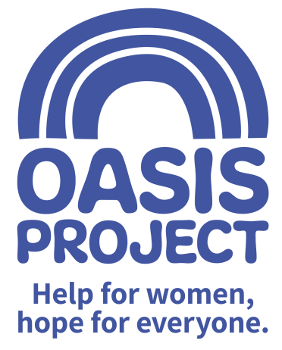
ROLE PROFILE
ROLE TITLE: Community Fundraiser | REPORTS TO: Head of Business Development
TEAM: Fundraising | SALARY: £19,000 per year fte
HOURS: 22.5 hours per week including some flexible working and unsociable hours at promotional events.
PURPOSE OF ROLE: To develop and grow the community fundraising function for Oasis, securing new income through events, individual giving, online fundraising and corporate fundraising. To raise the profile of the charity in the wider community. The role will involve organising events, assisting with fundraising applications and engaging with individuals, groups, clubs and associations to seek support from local and regional companies. Communicating key messages about Oasis to inspire and engage supporters will be key, as will successful stewardship of new and existing supporters. The post-holder will work with the Senior Management Team and other staff and trustees to implement Oasis’ fundraising strategy with the aim of delivering sustainable income.

SUMMARY:

The successful candidate will be a self-motivated and driven individual with buckets of creativity and enthusiasm. The post-holder will bring knowledge and experience of different methods of fundraising and be able to support other groups and individuals fundraising on Oasis’ behalf. Experience in organising events is essential. The post-holder will be out-going and a passionate advocate and representative of Oasis. A strong competency in communication (both verbal and written) will be key as will the understanding of budgets and general numeracy.
Key competencies
Income generation, fundraising systems & processes
- To lead on engagement with the community in order to generate income and increase Oasis’ supporter base, developing fundraising opportunities that can be turned into income generation activities
- Identifying and developing relationships with potential financial supporters such as community groups, schools, societies, clubs etc.
- Identifying key individuals who have the interest and capacity to fundraise for Oasis, supporting them in their activities and/or as they develop their own fundraising groups, including giving presentations on Oasis as necessary and training them to present on Oasis’ behalf
- To organise, market and run fundraising activities, events in line with the Oasis branding. Promote these events through a variety of different channels to reach a wider community, deliver outstanding service to attendees and participants at the events
- Working with the Fundraising Assistant support, develop and plan for small to medium sized fundraising events and initiatives
- Identifying and approaching local companies who have the capacity and propensity to support Oasis financially and in other unique ways (e.g. GIK)
- Supporting the Head of Business Development in writing funding proposals to trusts and foundations
- Undertaking research to identify trust funds, grants and other sources of funds that Oasis could apply for
- Ensuring that Oasis deliver quality and timely thanking, stewardship and reporting back to funders, companies and supporters in order that their support is recognised, retained and repeated.
- Maintaining up to date accurate records around funders and supporters using a database, including working with the Head of Business Development to report and review progress, next actions and plans.
Communication and networking
- Create informative and exciting publicity material and fundraising materials consistent with Oasis branding guidelines, to aid fundraising opportunities and ensure that this is available for use by other employees and at fundraising events.

- To provide a point of contact for all communication regarding fundraising by telephone, email and in person as appropriate

- To support members of the community to run their own events and raise money and/or volunteer their time on behalf of Oasis

- To ensure that the Oasis website has a section on fundraising that remains accurate, up to date, and includes content that is uploaded in a timely and professional manner.
- To use social media to promote Oasis services and fundraising activity.

- To provide clear communications about Oasis’ work and be able to provide varied information with a wide range of audiences.

- To be a passionate advocate of Oasis’ services.

- To represent Oasis at relevant networking events and promote its services.
Budgetary responsibilities
- Keep clear and up to date records of funding to feed into reports to the CEO and the Board of Trustees about fundraising levels and activity.

- Work with financial and communications lead to maintain accurate and careful monetary records.
- Be able to work to and exceed targets
General accountabilities
- Flexibility and willingness to travel to support fundraising activities, and events including some evening and weekend working.
- Demonstrate commitment to the vision and values of Oasis and understand how own behaviour and actions contribute to maintaining a culture of shared ownership and responsibility that supports Oasis in achieving its overall vision
- Ensure adherence to health and safety legislation
- Promote and embrace equality and diversity
- Ensure adherence to policy and practice
- Participate in supervision in line with the organisations' approach
- Carry out from time to time any other appropriate duties as directed by management to support and promote the work of Oasis

PERSON SPECIFICATION | Essential or Desirable
QUALIFICATIONS
Minimum of 5 GCSE Grade C or above (or equivalent) including English and Maths | Essential
Institute of Fundraising Certificate | Desirable
EXPERIENCE
At least 1 years’ experience of working in a fundraising environment or transferable skills from a sales or marketing background | Essential
Comprehensive experience of using Microsoft Office (including Outlook, Word, Excel and Powerpoint) | Essential
Experience of working with administrative systems and using databases to systematically record information and report from it | Essential
Managing multiple priorities in an effective, efficient and organised manner | Essential
Writing clear and informative copy for internal and external communication purposes | Essential
Experience of researching and presenting information clearly and concisely | Essential
Experience at organising and managing events | Essential
Experience of preparing and writing bids and funding applications | Desirable
Experience of working to and exceeding targets | Desirable
Experience at co-ordinating volunteers | Desirable
SKILLS
Excellent interpersonal, communication and presentation skills | Essential
Confident telephone manner | Essential
Good working knowledge and awareness of social media opportunities | Desirable
Ability to build and maintain good working relationship with a diverse range of people | Essential
Able to prioritise and meet deadlines with minimal supervision | Essential
Numerate and financially literate | Essential
Able to motivate and influence others | Essential
KNOWLEDGE AND PERSONAL ATTRIBUTES
Knowledge of different methods of fundraising | Essential
Enthusiastic and creative and keen to find solutions to problems | Essential
Self motivated and able to use own initiative | Essential
An understanding and commitment to the principles of equality and diversity | Essential
To understand the importance of taking responsibility for own behavior and actions | Essential
Committed to continued professional development including active participation in internal and external meetings and training | Essential
Able and willing to travel and occasionally work at weekends and evenings | Essential
An understanding of and an interest in the issues surrounding substance misuse and women-only services | Desirable
Knowledge of local business networks and community groups | Desirable

The post is not subject to the satisfactory completion of a Disclosure and Barring Service check at a standard level. This job description accurately reflects the present position; it may be reviewed and amended but only after a proper period of consultation.

