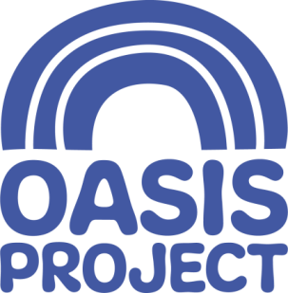

Community Fundraiser – Part Time
£19,000 per year FTE
22.5 hours per week over 3 days (with occasional weekend and evening work)
This is a permanent contract
This post is based in Brighton but travel to other Sussex locations may be occasionally required

Who we are:
For 21 years Brighton Oasis Project (Oasis) has delivered services for women with drug and alcohol problems and children affected by drug use in the family. We are an innovative, creative and forward-thinking organisation, which aims to empower women, children and young people affected by substance misuse. We give help and hope to women and children affected by drug and alcohol problems.

About the role:
The Community Fundraiser role is part of the fundraising team who support the organisation to meet its targets by securing new income through community fundraising events, individual giving, online fundraising and corporate fundraising.
What you will do:
The post holder will be involved in organising events, assisting with fundraising applications and engaging with individuals, groups and local and regional companies. The role will involve communicating key messages about the work of Oasis to inspire and encourage financial support and engagement with the organisation by others. The post holder will be self-motivated, creative and highly organised.
You will:
- Have 5 GCSE Grade C or above (or equivalent) including English and Maths;
- Have experience of working in a fundraising environment or transferable skills from a sale, marketing or events background
- Have comprehensive understanding of Microsoft office
- Be experienced at working within administrative systems and using databases
- Be able to manage multiple priorities in an effective, efficient and organised manner
- Experienced at writing clear and informative copy for varying communication purposes
- Have experience of organising and managing events
- Have good working knowledge and awareness of social media and its uses
- Be confident and be able to demonstrate excellent interpersonal skills
- Ideally have knowledge of local business networks and community groups as well as an understanding of issues surrounding substance misuse and women-only services.

What we offer:
- Generous holiday entitlement
- Access to training and development
- Central Brighton location

For a full job description, person specification and application pack, please visit our website www.oasisproject.org.uk; or you can email recruitment@oasisproject.org.uk. If you would like to chat to someone about the role, please contact Laura Ward, Head of Business Development.

- Closing date for applications is 9am on Monday 6 January 2020
- Interviews will take place on Friday 10 January 2020

If you have not heard from Oasis by 9 January, you will not have been successful on this occasion; but we thank you for your interest.

Application is by application form only, please do not send a CV as this will not be accepted as an application. Please do complete the equality and diversity monitoring form and send with your application.

Charity no: 1065503 Company no: 3447762
Oasis is committed to equal opportunities and welcomes applications from people with relevant life as well as professional experience, and those with disabilities who are currently under-represented in the organisation. People from Black and Minority Ethnic communities are underrepresented in our organisation and we particularly welcome applications from this group.

