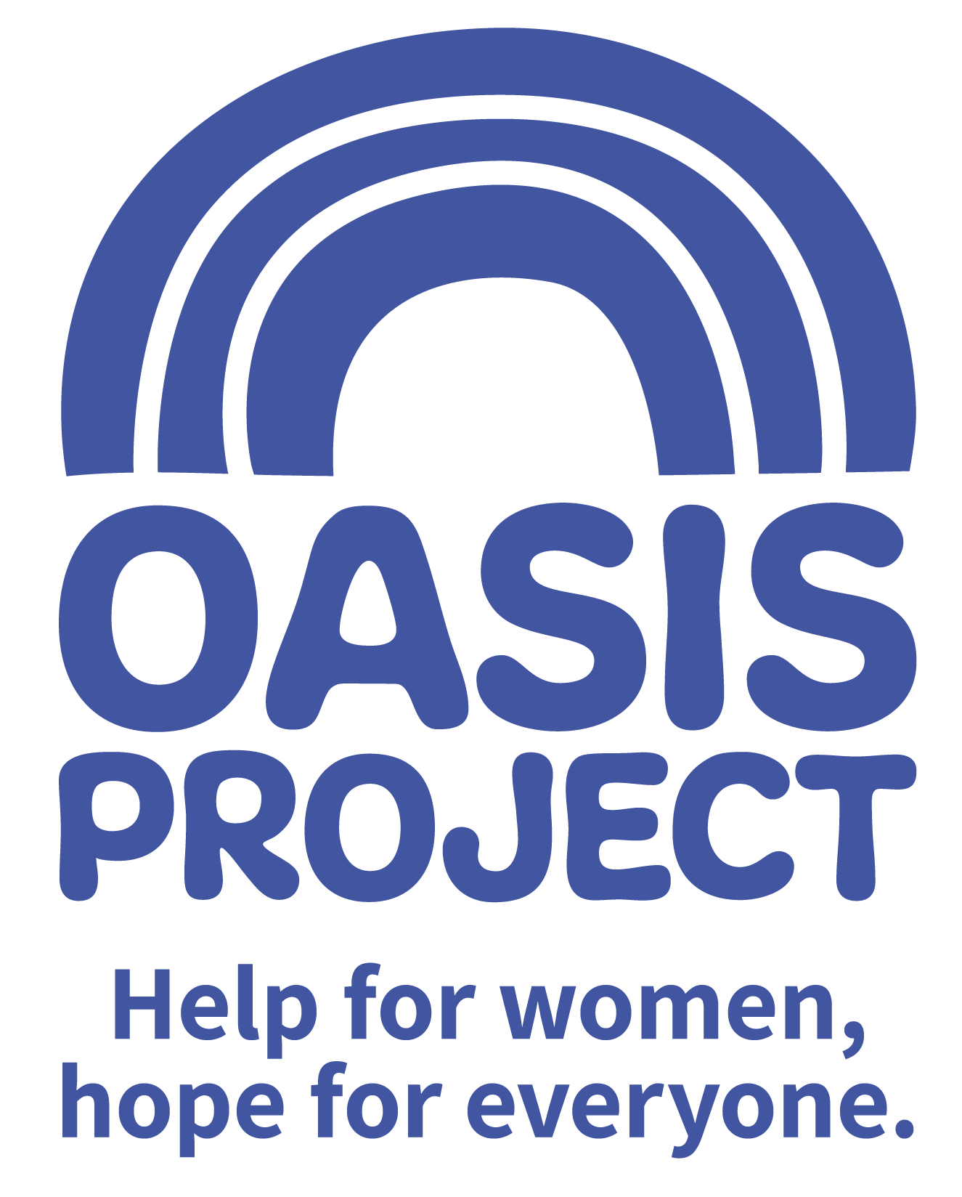

Female* OWRS Manager / East Sussex Lead

£33,000 per year FTE
30 hours per week (working pattern to be agreed at interview)
Permanent contract – with 6 month probation

- This post is only open to female applicants as being female is deemed to be a genuine occupational requirement under Schedule 9, Paragraph 1 of the Equality Act 2010.

Thank you for your interest in Oasis Project and the role of OWRS Manager/East Sussex Lead.

This is your application pack. It will tell you about our activities and how you can apply for this role. After reading the pack we hope you will still be interested in applying and ask that you complete the application form and return it to us:

- By email to recruitment@oasisproject.org.uk
- Send by post to Globe House, 3 Morley Street, Brighton, BN2 9RA

Closing date for applications is 9 am on Monday 28 October 2019
Interviews will take place on Wednesday 6 November 2019. The interview process will involve a series of competency based interview questions and there is the possibility of a test/presentation.

We hope the successful candidate will be able to start as soon as possible, once recruitment checks are completed.

You will find the following enclosed within this pack:

- Introduction to Oasis Project

- Working at Oasis Project

- The recruitment process

  - Selection
  - Job description and person specification
  - Completing your application
  - Submitting your completed application
  - References, occupational health checks, UK work eligibility checks and DBS disclosure

Introduction to Oasis Project
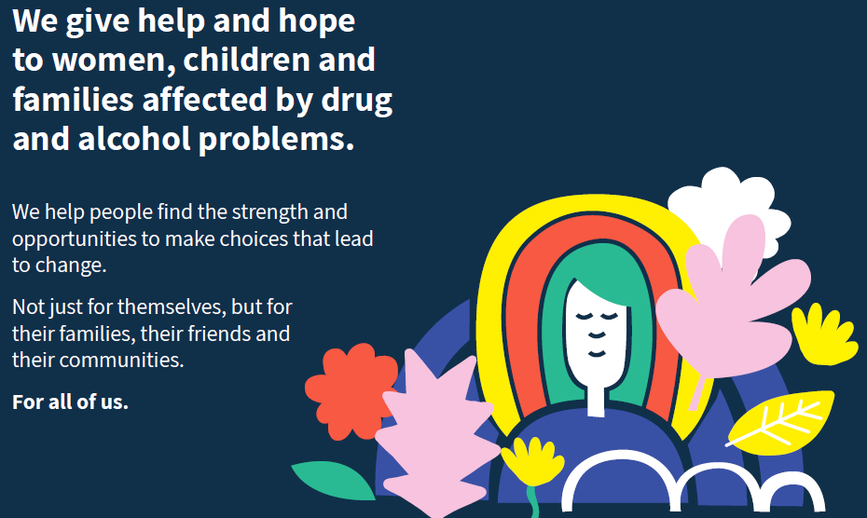

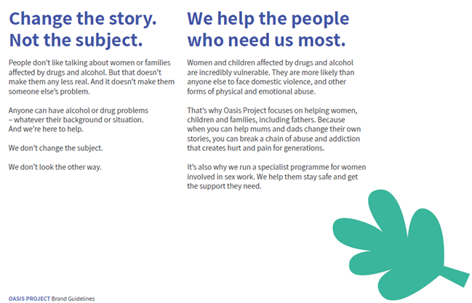

Working at Oasis Project:

Our vision and values underpin the services provided and how they are delivered to clients, as well as to how its employees and volunteers are treated.

We are a small to medium sized organisation. We have approximately 50 employees working a range of flexible hours. This means we are small enough to encourage collaborative working, learning from each other, make decisions quickly and enjoy working in a dynamic and exciting environment. We welcome the views of everyone within the team regardless of length of service and will value your views, perspectives and opinion.

Whilst we enjoy working as a team, the organisation has some key areas of work.
- Young Oasis team (made up of the crèche, therapy services for young people, and young women’s alcohol services)
- Adult services team
- Sex workers outreach project
- Fulfilling Lives Project in East Sussex
- Smaller short term projects
- Administrative and fundraising functions.

As a paid employee at Oasis, you will be expected to:
- Meet the skills and requirements as outlined in the job description and person specification for this role;

- Make sure that you can commit to the specific hours and days of work that the role requires;

- Make sure that you are able to travel to and from the Hastings Oasis office and occasionally to the Brighton Oasis project offices based at 11 Richmond Place, Brighton and at Globe House, 3 Morley Street, Brighton (or other work venue as required).

- Discuss and agree any support needed with your line manager or the CEO of the project and/or the Human Resources Adviser.

- Engage with a culture of continuous professional development

- Observe the relevant requirements of all Oasis Project policies.

In return you can expect

Challenge and experience

This role offers a fantastic step to make your mark in the organisation and continue the development of the OWRS project, with opportunities to demonstrate your creativity, resilience, and enthusiasm.

Training and support

Oasis Project provides you with regular one to one sessions with your line manager and an annual appraisal to review progress and identify areas for development. We also strongly encourage continuous professional development and encourage learning from a range of different opportunities.

We like to develop talent and provide opportunities such as secondments to ensure our employees continue to grow and learn, and can remain motivated and passionate about their work.

Benefits

In return for your time and skills at work you will receive
- a fair salary, comparable with similar roles in the area.
- 28 days (210 hours) annual leave plus bank/public holidays pro rata (full time) or pro rata equivalent
- A Well-Being hour monthly (1 paid hour leave per month for a well-being activity)
- Training and learning opportunities
- Study leave for approved courses/training
- An employer contribution of 3% into our stakeholder pension scheme via Bluesky (on condition that you remain enrolled in the pension scheme and contribute a minimum of 5% of your salary).
- Free tea and coffee
- Occupational health – eye tests reimbursed; other health support provided as necessary.

Career and other benefits

Oasis Project aims to be an employer of choice. We are a professional, well-respected organisation and showing that you have been employed here is great experience to put on your CV. We hold the Investors in People external accreditation.
Insurance

All employees are covered by Oasis Project’s insurance policy. To ensure that you have adequate cover it is important that you follow the guidelines of your role at all times.

THE RECRUITMENT PROCESS
At Oasis Project we are committed to providing the best possible recruitment service including working to remove barriers to equal opportunity at each stage of the recruitment process. Our commitment to you is that:

- We will treat you in a polite, helpful and friendly manner at all times.
- Information that you provide will be treated as confidential and will be seen only by those involved in the recruitment process.

- We will remove all personal information from your application to ensure that the short listing panel are not aware of whose application they are assessing.

- We will ask you to complete an equal opportunities questionnaire – this information is only used for monitoring purposes.

- We will endeavour to make any reasonable adjustments to the selection process (application form, interview or training) to enable individuals to participate equally

- If you are selected to progress to the next stage you will be advised as soon as possible.

- We will aim to give you at least one week’s notice prior to interview, or we will make it clear in the job advertisement when the interviews will be held.

- We will not contact your referees unless you give your permission. We will however need to obtain 2 satisfactory references as a condition of any employment offer.

- A decision will be made as soon as possible after interviews and you will be informed, normally within 1 week.

- Unsuccessful interviewees will be offered feedback.

Selection
Step 1: The first step is to fill in and submit an application form before the closing date. Once you’ve submitted your application form, we will assess whether or not you have demonstrated that you meet the criteria detailed on the person specification for the role.

Step 2: If you are shortlisted at the application stage, the second step will be that you are invited to attend an interview where we will assess whether you’re suitable for the role. You will be sent an interview invitation via email or letter. At the interview you will need to demonstrate that you can meet the criteria in the person specification.

Step 3: If you’re selected, the third step is to undertake pre-employment checks; Once in post you will undertake a thorough induction and complete the mandatory training programme.

Completing your application
You will need to download an application form. You can download this from the same page where you accessed this recruitment information pack. You can find information about all Oasis vacancies here: http://www.oasisproject.org.uk/job-vacancies/

You may submit either a typed or hand-written application and send this via email or in the post. If you decide to hand-write your application please ensures that it is legible. Please ensure that your personal information is completed including a contact telephone number if possible.

Please note that we do not accept CVs.

In your application you will need to demonstrate that you have the skills to meet the requirements of the role. Please read the job description and person specification carefully and address your supporting statement to the stated criteria.

It is important and very helpful if you can complete the Equal Opportunities Monitoring form as this helps us to monitor our recruitment process and ensure that we are attracting a diverse range of people to want to work and volunteer at Oasis.

Submitting your application

By email: Please email your completed application form and equal opportunity form to recruitment@oasisproject.org.uk

By post: Please send your completed application form and equal opportunity form to: Administration Manager, Globe House, 3 Morley Street, Brighton, BN2 9RA

Methods of assessment
A range of methods, (although the same for each person) will be used to assess each application that is received for the role. These will include:
- Application form and supporting statement
- Checking qualifications against certificates / registrations with professional bodies
- Interview
- Possible test (such as typing test, report writing, data entry, presentation). You will be informed in advance if a test will be used during an interview process.
- References

Recruitment checks:

References
We require two references. They will not be contacted without your permission but we will need
to obtain two satisfactory references before you can take up any employment offered to you. If
you can provide an email address for your referees this is helpful.

Eligibility to work in the UK
We require you to provide appropriate ID documentation that proves your eligibility to work in
the UK.

Occupational health check
You will be asked to complete an online medical questionnaire, via our occupational health
providers. Our occupational health experts will confirm to Oasis Project whether you are fit (or
not fit) to undertake the role, or if adjustments may be required, based on the information that
you have disclosed.

Ex-offenders / Disclosure and Barring Service (DBS) Checks
All applicants are required to disclose details of any unspent convictions in accordance with the
Rehabilitation of Offenders Act 1974. Any disclosure of an unspent conviction will NOT
automatically disqualify your application unless the nature of the offence renders you unsuitable
for the role. All such disclosures will be considered on an individual basis. There is space on the
application form for this information.

If your employment at Oasis will include working with children and vulnerable adults you will
be required to undertake a DBS check (with the costs for this being met by Oasis).

We wish you success with your application.
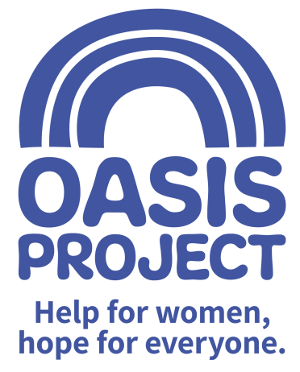

Role profile:
Role title: Oasis Women’s Recovery Service (OWRS) Manager and Oasis Lead in East Sussex | Reports to: Chief Executive
Team: Oasis Women’s Recovery Service | Salary: £33,000
Hours: 30 hours - negotiable

Contract type: Permanent

Responsible for: Management of the OWRS Project; line management for OWRS project workers;
Oversight of operational aspects of the Hastings Therapy Services; Provision of
Senior management cover in East Sussex
Purpose of the role:
To provide leadership and management of a women’s drug project which aims to increase access to support for women and improve recovery rates in East Sussex. This will include:
- Management of OWRS to include line management and reporting requirements , liaison with funders
- To manage risk and ensure appropriate safeguarding procedures are adhered to
- To work in close partnership with our partners in East Sussex e.g. CGL and Mental Health services
- To be part of Oasis management team and contribute to service development

Responsibilities:
Client Service Delivery
- Be creative and innovative in delivery of a high quality women centred service provision
- Promote the rights and responsibilities of women with substance misuse issues
- Carry out and support staff to assess to identify and prioritise needs
- Develop, in conjunction with service users, flexible, realistic and person centred care plans within agreed service models
- Promote choice and independence, actively encourage service user involvement
- Support and encourage women to access and use services and facilities and signpost services including learning, training and development opportunities; housing and accommodation; and enabling individuals to administer their financial affairs
- Provide advice and information to women and their families regarding their support
- Recognise indicators of substance misuse including problematic use of alcohol, working to reducing risk of harm and encourage women to make informed choices
- Enable individuals to adopt safer practice associated with substance misuse
- Support individuals in reducing substance misuse
- Support women with substance misuse issues, including alcohol, in a range of difficult times, such as when distressed, at risk of harm, dealing with relationship problems

Leadership and Management
- To lead and manage the OWRS service which includes the management of staff.
- To be the Oasis Lead in East Sussex available for wider staff and practicalities of the building.
- To be a role model whilst working as an effective member of the team;
- To work in a way that is flexible and creative and which promotes inclusivity.
- To encourage collaborative working to manage risk;
- To provide managerial and reflective supervision for staff.
- To promote staff development through supervision and appraisal processes.
- To meet key performance indicators and expectations of the service.
- To analyse data and produce reports for purposes of oversight and evaluation in meetings and funders.
- Monitoring the team’s performance to ensure it meets expectations and agreed performance targets;
- Reporting any variances in expected outcomes to the line manager;
- Attending relevant internal and external meetings

Adult and Child Safeguarding
- Be committed to the safeguarding of children and adults affected by substance misuse
- Excellent safeguarding practice and procedures, making awareness of documentation pathways at Oasis a priority and taking appropriate action as necessary
- Seek advice from Head of Client services for support.
- To keep up to date with training
Service commitment, collaboration and accountability
- Lead and contribute to the service delivery planning process of integrated programmes of care to achieve outcomes for women with substance misuse issues
- Manage a caseload of service users
- Make referrals, where necessary, to the appropriate organisations
- Work and build partnerships with relevant agencies to enable better access and integration of services,
- Engage in regular supervision
- Ensure adherence to evidence based practice and clinic guidelines
- Ensuring that Oasis and its services are represented in a professional manner at all times
- Meeting agreed performance targets and outcomes

Values and Ethos
- Demonstrate commitment to the vision and values of Oasis and understand how your own behaviour and actions impact this
- Contribute to maintaining a culture of shared ownership and responsibility that supports Oasis in achieving its overall mission.
- Understand and commit to equality, diversity and inclusion best practice with a particular focus on hard to reach and marginalised women service users.
- Be aware of and commit to working in a way that is ‘trauma informed’ and recognise this approach as part of Oasis’ overall commitment to providing gender responsive services
- Observe professional boundaries in relationships with service users, peers and other relevant professionals
- Participate in the continuous improvement of Oasis’ services

Compliance
- Ensure that Oasis and its services are represented in a professional manner at all times
- Meet agreed performance targets and outcomes
- Use management information and data as appropriate
- Comply at all times with health and safety regulations
- Ensure risk assessments are completed as appropriate
- Take personal responsibility for own safety
- Comply with all relevant policy and procedure, standards and codes of conduct
- Meet all regulatory requirements
- Comply with Oasis’ policy and procedure particularly confidentiality and data protection guidance
- Use IT and databases to keep records up to date in line with agreed processes
- Undertake any other reasonable duties as requested by the line manager

Communication and Relationships
- Provide information and raising awareness about substances, their use and effects on an individual basis and via facilitating collaborative group learning;
- Ensure a collaborative approach is used, ensuring effective communication within a multi-disciplinary team
- Contribute to the prevention and management of abusive, aggressive and challenging behaviour
- Work as an effective member of the team
Problem Solving and analysis
- Develop and disseminate information and advice about health and social well being
- Apply recognised theoretical models to enable individuals and groups to identify and explore concerns relating to their substance misuse
- Carry out testing and comprehensive assessment to identify alcohol and other substances
- Contribute proactively to the principle of continuous improvement by making positive suggestions and constructive feedback and helping with the implementation of agreed new ways of working

Continuous Development
- Reflect on and develop your own practice
- Monitor your own performance to ensure it meets expectations and agreed performance targets
- Make use of supervision opportunities, ensuring there is two-way dialogue
- Participate in training and other development opportunities
- Contribute to the development and knowledge of others by sharing your experience and skills

PERSON SPECIFICATION | Essential or Desirable
QUALIFICATIONS
NVQ level 3 in health and social care (or equivalent) | Desirable
Social work qualification | Desirable
SKILLS, EXPERIENCE AND EXPERTISE
Prior experience of managing and supervision staff | Essential
Proven track record of working within the substance misuse sector and managing a complex caseload | Essential
Experience of working with female substance misusers and understanding the issues faced by substance misusers | Essential
Experienced in providing effective performance management | Essential
To have an understanding of working in a way that is ‘trauma informed’ | Essential
Experience of working with women who have been victims of violence including sexual violence and exploitation | Essential
Proven track record in managing incidents of aggression and challenging behaviour | Essential
Experience of delivering group work or group based activities | Essential
Experience of providing community based support practices and of working in partnership with other partner agencies | Essential
Skilled in carrying out administrative duties including data entry and report writing | Essential
Experience of service user involvement and co production | Desirable
ABILITIES AND ATTITUDES
Committed to safeguarding with regard to adults and children | Essential
Committed to the principles of equal opportunity and diversity | Essential
Able to maintain professional boundaries | Essential
To be aware of best practice and confidentiality procedures in line with 2018 Data Protection Act guidelines | Essential
Proven verbal and written communication skills with the ability to tailor the message to the audience | Essential
Ability to lead and work effectively as part of a team | Essential
To be able to confidently use own initiative and follow through on decision making and taking action | Essential
Adaptable and able to work in a challenging and changeable environment, both on own and in a team | Essential
Ability to deliver against agreed objectives and targets and understand the importance of working efficiently | Essential
To understand the importance of taking responsibility for own behaviour and actions | Essential
Is able to travel with ease between different locations in East Sussex | Essential

The post is subject to the satisfactory completion of a Disclosure and Barring Service at an enhanced level.
This job description accurately reflects the present position; it may be reviewed and amended but only after a proper period of consultation.

