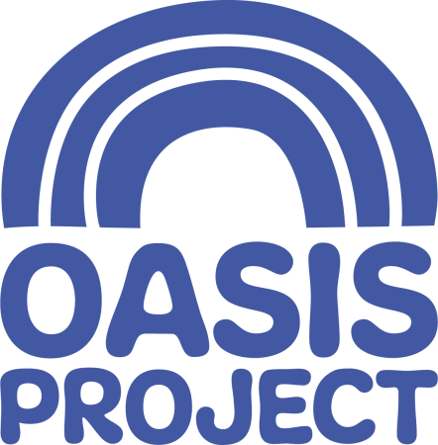

OWRS Manager and East Sussex Lead (Female*)
Based in Hastings
£33,000 per year FTE
Hours: 30 hours (working pattern negotiable)
Contract: permanent

Who we are
For 21 years Brighton Oasis Project (Oasis) has delivered services for women with drug and alcohol problems and children affected by drug use in the family. We are an innovative, creative and forward thinking organisation, which aims to empower women affected by substance misuse. We give help and hope to women and children affected by drug and alcohol problems.

About the role
This is a key role working within our East Sussex teams. You will provide leadership and management of this women’s drug project which aims to increase access to support for women and improve recovery rates in East Sussex. You will also act as a lead for the organisation in East Sussex.
What you will do
Your tasks will include:
- Management of OWRS to include line management and reporting requirements , and liaison with funders
- Management of risk and ensuring appropriate safeguarding procedures are adhered to
- Close partnership working with our partners in East Sussex e.g. CGL and Mental Health services
- Being part of Oasis management team and contributing to service development

You will have
- Knowledge of the key issues facing substance misusers, in particular female substance misusers and a commitment to helping women access relevant support;
- Experience of working with women who have been the victims of violence
- Experience of delivering group based activities
- Experience of providing community based support practices and of working in partnership with other agencies;
- Resilient attitude and ability to work in a way that is reflective, adaptable and non-judgemental and adheres to professional boundaries at all times;
- Skills of being adaptable and able to work in a challenging and changing environment, both on own and supporting a team
- Knowledge and experience of safeguarding procedures and processes, confidentiality procedures and data protection guidelines;
- Proven track record in managing incidents of aggression and challenging behaviour.
- Ideally you will have a relevant qualification such as a social work qualification, Nursing RMN RGN or NVQ level 3 in health and social care (or equivalent) and you will have experience of encouraging service user involvement and co-production

What we offer
- Fair salary
- Generous holiday entitlement
- Access to training and development
- Value placed on employee well-being

For a full job description, person specification and application pack, please visit our website www.oasisproject.org.uk; or you can email recruitment@oasisproject.org.uk. If you would like to chat to someone about the role, please contact Jo-Anne Welsh, CEO, on 01273 696970

Closing date for applications is 9 am on Monday 28 October 2019

Interviews will take place on Wednesday 6 November 2019 in Hastings

Application is by application form only, please do not send a CV as this will not be accepted as an application. Should you have not heard from Oasis by 5 November 2019 you have not been successful on this occasion, but we do thank you for your interest in our organisation.

Charity no: 1065503 Company no: 3447762
Oasis is committed to equal opportunities and welcomes applications from people with relevant life as well as professional experience, and those with disabilities who are currently under-represented in the organisation. People from Black and Minority Ethnic communities are underrepresented in our organisation and we particularly welcome applications from this group.
* This post is only open to female applicants as being female is deemed to be a genuine occupational requirement under Schedule 9, Paragraph 1 of the Equality Act 2010.

