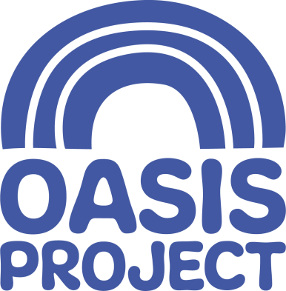

We are currently looking to recruit for an
Early Years Practitioner
Salary: £9.00 per hour
Working pattern: Mondays 9am to 4pm and Tuesdays 9am to 2.30pm (12 hours per week)
plus once a month attendance at team meeting (paid)

Who we are:
For over 21 years Oasis Project has delivered services for women with drug and alcohol problems and children affected by drug use in the family. We are an innovative, creative and forward thinking organisation, which aims to empower women, children and young people affected by substance misuse. We give help and hope to women and children affected by drug and alcohol problems. Our crèche is a vital function within Oasis in delivering our services.

What you will do in the role:
- You will help to ensure that our crèche provides a welcoming, safe, happy and fun environment where every child that attends can be settled and make good progress from their individual starting point.

You will have:
- Minimum of a level 2 childcare qualification and a willingness to work towards Level 3.

You will be able to demonstrate:
- An enthusiasm and love of working with children
- Creativity in developing and providing activities for children
- Confidence in your communications in all areas of your work
- An awareness of the importance of safeguarding (as the children attending the Oasis crèche can be particularly vulnerable)
- A keen interest in ongoing learning and your continuous professional development.
- Take on supervisory responsibilities at times and with support to cover days off and annual leave.

What we offer:
- Generous holiday entitlement
- Excellent training and development opportunities
- Awareness of the importance of employee well-being

Useful Information:
- For a full job description, person specification and application pack, please visit our website https://www.oasisproject.org.uk/job-vacancies/ or you can email recruitment@oasisproject.org.uk.
- If you would like to chat to someone about the role, please contact Joyce David on 01273 696970 Ext 304
- Closing date for applications is 9am on Monday 28 October 2019
- Interviews will take place Thursday 14 November 2019.
- Application is by application form only; please do not send a CV as this will not be accepted.

Oasis is committed to equal opportunities and welcomes applications from people with relevant life as well as professional experience, and those with disabilities who are currently under-represented in the organisation. People from Black and Minority Ethnic communities are underrepresented in our organisation and we particularly welcome applications from this group.

