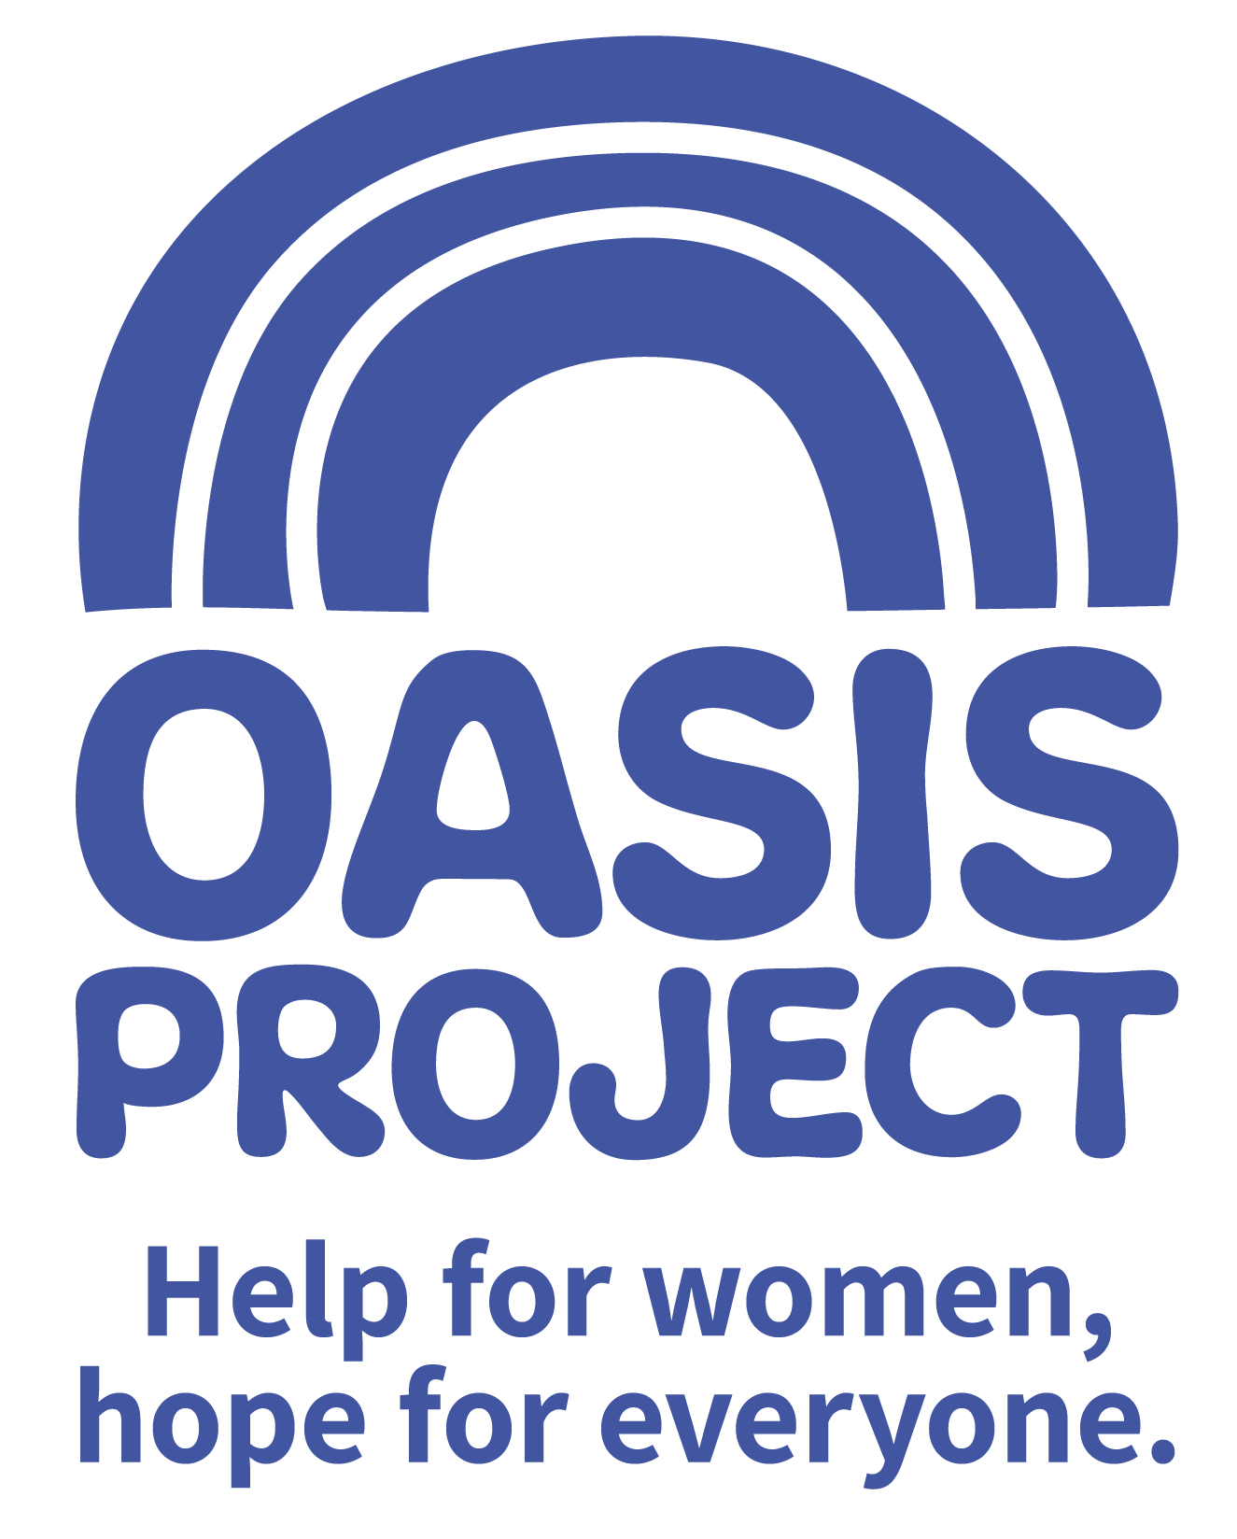

Early Years Practitioner

£9.00 per hour
12 hour per week over 2 days
Mondays 9am to 4pm and Tuesdays 9am to 2.30pm
plus once a month attendance at team meeting (paid)

The role is a permanent contract

Based in Brighton

Thank you for your interest in Oasis Project and the role of Early Years Practitioner.

This is your application pack. It will tell you about our activities and how you can apply for this role. After reading the pack we hope you will still be interested in applying and ask that you complete the application form and return it to us:

- By email to recruitment@oasisproject.org.uk
- Send by post to Globe House, 3 Morley Street, Brighton, BN2 9RA

Closing date is 9am on Monday 28 October 2019.

Interviews will be held on Thursday 14 November 2019. The interview process will involve a series of competency based interview questions and will give you an opportunity to see the crèche and the working environment.

We hope the successful candidate will be able to start as soon as possible.

You will find the following enclosed within this pack:

- Introduction to Oasis Project

- Working at Oasis Project

- The recruitment process

  - Selection
  - Job description and person specification
  - Completing your application
  - Submitting your completed application
  - References, occupational health checks, UK work eligibility checks and DBS disclosure

Introduction to Oasis Project
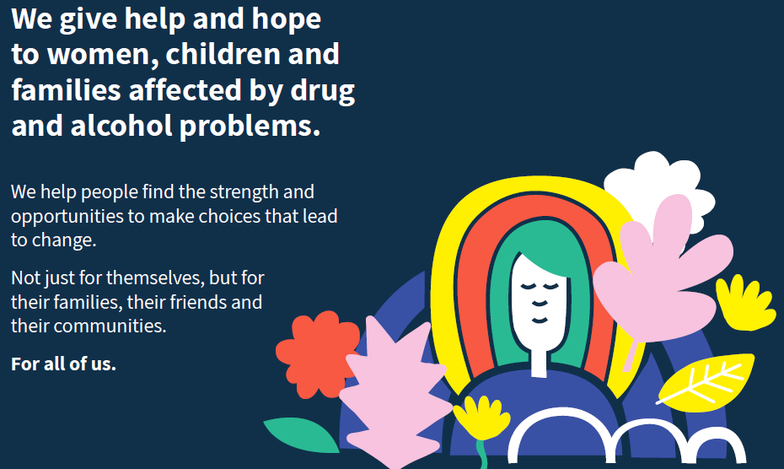

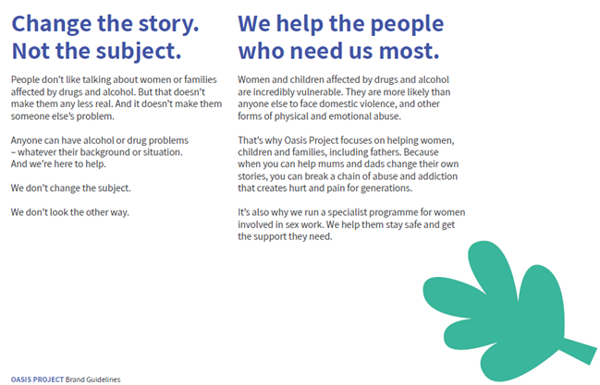

Working at Oasis Project:

Oasis Project aims to give help and hope to women, children and families in Brighton &Hove and across East Sussex affected by drug and alcohol problems.

We have been established for 22 years (since 1997) and take a gender-specific approach to service provision, working with all family members to achieve the best outcomes for our clients.

Last year we worked with over 600 women and over 200 children from Brighton & Hove and across East Sussex, around 40 men and women with multiple and complex needs in Hastings and Eastbourne through Fulfilling Lives and around 30 fathers.

Our main services for adults in Brighton & Hove include:

Open access (initial assessment for anyone referred or self-referring to Oasis)

Parenting Our Children Addressing Risk (POCAR) - a psycho-social programme for parents who use drugs and/or alcohol and have social services involvement with their children – including a specialist programme for dads delivered from a separate premises

Sex Workers’ Outreach Project (SWOP)

Assessment and care co-ordination

Structured group-work including Phase 2 for women seeking to take the next steps in their recovery

Peer support

Our Young Oasis service includes:

A therapeutic crèche for children aged 0-11 whose parents accessing treatment or support

One to one therapy for children and young people 5-18 affected by substance misuse in the family

A Young Women’s Therapy Service for women 18-25 who have experienced early trauma

Mellow Parenting – an attachment based parenting programme for mums who have experienced problems with substances
East Sussex services:

Groups and 1-1 keywork for women with a drug or alcohol problem

Therapy for children and young people 5-18 affected by substance misuse in the family

Delivery of Fulfilling Lives project in Hastings and Eastbourne

Recent service developments
Oasis is part of one of 8 local authority partnerships to have been awarded Public health England funding under their initiative to improve responses to children of alcoholics. The expectation is that this will increase the number of parents in treatment in the city.

Oasis has been commissioned by the Department of Work and Pensions under their Challenge Fund for Disadvantaged Families to undertake a 12 month project to develop an understanding of what works to reduce parental conflict and improve outcomes for families where there are drug and alcohol misuse issues, with a focus on engaging fathers in support. The project will be externally assessed by University of Sussex.

Our Ethos

Our Core Truths
- Anybody can develop a problem with drink or drugs – whatever their background or situation.
- It is harder for women to escape drug and alcohol problems – they need specialist help.
- Drug and alcohol problems don’t just affect the individual – but everyone around them.
- Drink and drug problems aren’t just the cause of a difficult life, they’re a symptom of one.
- A bad start in life doesn’t have to mean a bad end.
- We’re not here to ‘fix’ anyone – we’re here to help women make choices that lead to change.
- We know that one size doesn’t fit all – we look at the individual

Our Values
Equality
We are a champion for equality, providing a non-judgemental service which respects the needs of its clients in all their diversity and recognises that one size does not fit all.

Accountability
We do what we say we are going to do and work with integrity, never losing sight of our responsibility for our actions

Caring
We deliver all our services with respect for individuals and our day to day interactions are characterised by compassion and kindness

Creativity
We use our unique insight and experience to problem solve, recognising the value of innovation when working with individuals and families

Collaboration
We work together with our clients, their families friends and networks and our professional partners to provide the best care possible, to keep people safe and to bring about positive change

Learning
We continue to develop and evolve our services to better meet the needs of our clients, facilitating involvement and feedback at every opportunity

The above are underpinned by a 7th value, which is… Community

As a paid employee at Oasis, you will be expected to:

- Meet the skills and requirements as outlined in the job description and person specification for this role;

- Make sure that you can commit to the specific hours and days of work that the role requires;

- Make sure that you are able to travel to and from the Brighton Oasis project offices based at 11 Richmond Place, Brighton and at Globe House, 3 Morley Street, Brighton (or other work venue as required).

- Discuss and agree any support needed with your line manager or the Director of the project and/or the Human Resources Adviser.

- Engage with a culture of continuous professional development

- Observe the relevant requirements of all Oasis Project policies.

In return you can expect

Challenge and experience

This role offers a fantastic step to develop your career and make your mark in the organisation. It is a new role so you will be able to develop it and make a significant and immediate contribution.

Training and support

Oasis Project provides you with regular one to one sessions with your line manager and an annual appraisal to review progress and identify areas for development. We also strongly encourage continuous professional development and encourage learning from a range of different opportunities.

We like to develop talent and provide opportunities such as secondments to ensure our employees continue to grow and learn, and can remain motivated and passionate about their work.

Benefits

In return for your time and skills at work you will receive
- a fair salary, comparable with similar roles in the area.
- 28 days (210 hours) annual leave plus bank/public holidays pro rata (full time) or pro rata equivalent
- 1 hour per month for well-being
- Training and learning opportunities
- Study leave for approved courses/training
- Annual all-staff conference
- An employer contribution of 3% into our stakeholder pension scheme via Bluesky (on condition that you remain enrolled in the pension scheme and contribute a minimum of 5% of your salary).
- Free tea and coffee
- Occupational health – eye tests reimbursed; other health support provided as necessary.

Career and other benefits

Oasis Project aims to be an employer of choice. We are a professional, well-respected organisation and showing that you have been employed here is great experience to put on your CV. We hold the Investors in People external accreditation.
Insurance

All employees are covered by Oasis Project’s insurance policy. To ensure that you have adequate cover it is important that you follow the guidelines of your role at all times.

THE RECRUITMENT PROCESS
At Oasis Project we are committed to providing the best possible recruitment service including working to remove barriers to equal opportunity at each stage of the recruitment process. Our commitment to you is that:

- We will treat you in a polite, helpful and friendly manner at all times.
- Information that you provide will be treated as confidential and will be seen only by those involved in the recruitment process.

- We will remove all personal information from your application to ensure that the short listing panel are not aware of whose application they are assessing.

- We will ask you to complete an equal opportunities questionnaire – this information is only used for monitoring purposes.

- We will endeavour to make any reasonable adjustments to the selection process (application form, interview or training) to enable individuals to participate equally

- If you are selected to progress to the next stage you will be advised as soon as possible.

- We will aim to give you at least one week’s notice prior to interview, or we will make it clear in the job advertisement when the interviews will be held.

- We will not contact your referees unless you give your permission. We will however need to obtain 2 satisfactory references as a condition of any employment offer.

- A decision will be made as soon as possible after interviews and you will be informed, normally within 1 week.

- Unsuccessful interviewees will be offered feedback.

Selection
Step 1: The first step is to fill in an application form before the closing date. Once you’ve submitted your application form, we will assess whether or not you have demonstrated that you meet the criteria detailed on the person specification for the role.

Step 2: If you are shortlisted at the application stage, the second step will be that you are invited to attend an interview where we will assess whether you’re suitable for the role. You will be sent an interview invitation via email or letter. At the interview you will need to demonstrate that you can meet the criteria in the person specification.

Step 3: If you’re selected, the third step is that you will undertake a thorough induction and complete the mandatory training programme.

Completing your application
You will need to download an application form. You can download this from the same page where you accessed this recruitment information pack. You can find information about all Oasis’ vacancies here: http://www.oasisproject.org.uk/job-vacancies/

You may submit either a typed or hand-written application and send this via email or in the post. If you decide to hand-write your application please ensures that it is legible. Please ensure that your personal information is completed including a contact telephone number if possible.

Please note that we do not accept CVs.

In your application you will need to demonstrate that you have the skills to meet the requirements of the role. Please read the job description and person specification carefully and address your supporting statement to the stated criteria.

It is important and very helpful if you can complete the Equal Opportunities Monitoring form as this helps us to monitor our recruitment process and ensure that we are attracting a diverse range of people to want to work and volunteer at Oasis.

Submitting your application

By email: Please email your completed application form and equal opportunity form to recruitment@oasisproject.org.uk

By post: Please send your completed application form and equal opportunity form to: Administration Manager, Globe House, 3 Morley Street, Brighton, BN2 9RA

Methods of assessment
A range of methods, (although the same for each person) will be used to assess each application that is received for the role. These will include:
- Application form and supporting statement
- Checking qualifications against certificates / registrations with professional bodies
- Interview
- Possible test (such as typing test, report writing, data entry, presentation). You will be informed in advance if a test will be used during an interview process.
- References

Recruitment checks:

References
We require two references. They will not be contacted without your permission but we will need
to obtain two satisfactory references before you can take up any employment offered to you. If
you can provide an email address for your referees this is helpful.

Eligibility to work in the UK
We require you to provide appropriate ID documentation that proves your eligibility to work in
the UK.

Occupational health check
You will be asked to complete an online medical questionnaire, via our occupational health
providers. Our occupational health experts will confirm to Oasis Project whether you are fit (or
not fit) to undertake the role, or if adjustments may be required, based on the information that
you have disclosed.

Ex-offenders / Disclosure and Barring Service (DBS) Checks
All applicants are required to disclose details of any unspent convictions in accordance with the
Rehabilitation of Offenders Act 1974. Any disclosure of an unspent conviction will NOT
automatically disqualify your application unless the nature of the offence renders you unsuitable
for the role. All such disclosures will be considered on an individual basis. There is space on the
application form for this information.

If your employment at Oasis will include working with children and vulnerable adults you will
be required to undertake a DBS check (with the costs for this being met by Oasis).

We wish you success with your application.

ROLE PROFILE
ROLE TITLE: EARLY YEARS PRACTITIONER | REPORTS TO: Early Years Supervisor
TEAM: Young Oasis | SALARY: £9.00 per hour (B&H Living Wage)
RESPONSIBLE FOR: No line management responsibilities | HOURS: tbc

SUMMARY:

You will be a creative, caring and enthusiastic person who loves working with children. You will contribute to ensuring that the crèche provides a welcoming, happy and safe environment where every child is settled and making good progress from their individual starting point. Children who attend the Oasis crèche can be particularly vulnerable and you will be responsible for ensuring safeguarding procedures are prioritised at all times, following all safeguarding procedures. You will be a confident communicator and enjoy working in a team. You will demonstrate a keen interest in learning and development. You will take on supervisory responsibilities at times to cover days off and annual leave.

Early Years and crèche provision
- To contribute to providing a high standard of physical, emotional, social and intellectual care and development for children within the crèche
- To contribute to ideas for the yearly programme of activities and fulfil this
- To help identify the physical, emotional, intellectual developmental needs of each child and offer appropriate support and relevant developmental opportunities, including updating records.

Safeguarding
- Demonstrates confidence and understanding in safeguarding procedures

Communication
- Can be a confident communicator and good listener.

Team player
- Will demonstrate enthusiasm and positivity within the crèche team and wider organisation
- Will contribute and actively engage in crèche team meetings
- Will take on supervisory responsibility in the crèche occasionally to cover absence

General accountabilities
To meet all other expectations of the role by:-
- Demonstrating commitment to the vision and values of Oasis and an understanding how own behaviour and actions contribute to maintaining a culture of shared ownership and responsibility that supports Oasis in achieving its overall vision
- Demonstrating awareness and commitment to working in a way that is ‘trauma informed’ and to recognise this approach as part of BOP’s overall commitment to providing gender responsive services for women.
- Maintaining awareness of all current Health and Safety legislation and demonstrate a commitment to working within and promoting safe practice;
- Promoting and embracing all aspects of equality and diversity;
- Following and adhering to all policy and procedure within the organisation particularly confidentiality and data protection guidelines;
- Actively participating in all appropriate meetings and training and learning opportunities;
- Providing timely and appropriate feedback through supervision sessions, and actively participating in these sessions;
- Supporting, promoting and working in accordance with all of BOP’s aims and objectives;
- Carrying out from time to time any other appropriate duties as directed by management to support and promote the work of BOP, in accordance with the post holder’s capabilities.

PERSON SPECIFICATION | Essential or Desirable
QUALIFICATIONS
Level 2 childcare qualification or degree in Early Years | Essential
Working towards or willing to work towards Level 3 childcare qualification | Essential
First Aid (general) | Desirable
First Aid (pediatrics) | Desirable
KNOWLEDGE, SKILLS AND EXPERIENCE
At least 1 year relevant significant experience of working with children and families in an early years setting | Essential
Demonstrable experience of safeguarding children legislation and processes | Essential
Experience of implementing a varied range of activities with children and generating new activities and creative ideas. | Essential
Skilled at using Microsoft office packages including outlook, word, powerpoint | Essential
Experienced at communicating clearly and confidently to a range of audiences | Essential
Knowledge and understanding of the current EYFS curriculum | Desirable
An understanding of current issues related to substance misuse and families experiencing problems | Desirable
To have an understanding of working in a way that is ‘trauma informed’ | Desirable
ATTITUDE AND BEHAVIOURS
To demonstrate an enthusiastic and motivating attitude | Essential
An understanding and commitment to the principles of equality and diversity and an ability to engage with children and adults from diverse backgrounds. | Essential
To understand the importance of taking responsibility for own behavior and actions | Essential
To be aware of best practice around confidentiality procedures and a clear understanding of data protection guidelines | Essential
Committed to continued professional development including active participation in internal and external meetings and training | Essential

The post is subject to the satisfactory completion of a Disclosure and Barring Service check at an enhanced level.

This job description accurately reflects the present position; it may be reviewed and amended but only after a proper period of consultation.

