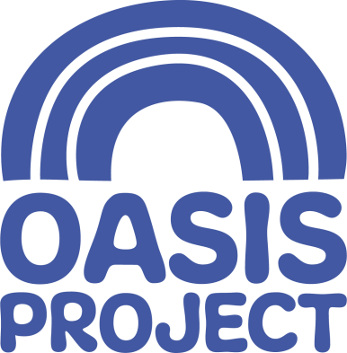
We are currently looking to recruit for the position of:
Receptionist/Administrator
Female*, 15 hours per week over two days (to be agreed at interview)
Salary: £8.21 per hour

Who we are:
For 21 years Oasis Project (Oasis) has delivered services for women with drug and alcohol problems and children affected by drug use in the family. We are an innovative, creative and forward thinking organisation, which aims to help and give hope to women and children affected by drug and alcohol problems.

About the role:
The Receptionist/Administrator provides a high quality, client centred reception service and has a key role in welcoming and directing a wide range of people to Oasis’ services. The successful candidate will provide administrative support to the team and therefore must be able to deal with conflicting priorities in a calm and organised manner. The role involves direct contact with service users and their children and is an important public face of the organisation.

What you will do:
- Provide a professional, friendly first point of contact for information about the service;
- deal effectively with telephone callers and visitors to reception;
- respond to general email enquiries;
- ensure the service centre remains women-only, responding efficiently and appropriately to all visitors to the premises;
- assist with photocopying, ordering of office supplies, filing diary management and other administrative tasks; and
- ensure the reception area is tidy and effectively organised.
You will have:
- A pro-active, self starting and self-motivating attitude;
- experience of dealing positively and professionally with the general public;
- experience of working well in a team;
- an understanding of working confidentially;
- good working knowledge and understanding of relevant IT packages; and
- be educated to GCSE Grade C (or equivalent) in Maths and English.

What we offer:
- Generous holiday entitlement
- Excellent training and development opportunities
- Wellbeing packages

For a full job description, person specification and application pack, please visit our website www.oasisproject.org.uk or e-mail recruitment@oasisproject.org.uk

If you would like to chat to someone about the role, please contact Lisette Whittaker/Charis Bull on 01273 696970

Closing date for applications is 9 am on Monday 23 September 2019
Interviews will take place on Friday 4 October September 2019

Application is by application form only (not CV). Please ensure you refer to the Job Description and Person Specification in your application form. Send your completed application form, Equality and Diversity monitoring form to recruitment@oasisproject.org.uk.

*This post is only open to female applicants as being female is deemed to be a genuine occupational requirement under Schedule 9, Paragraph 1 of the Equality Act 2010
Oasis is committed to equal opportunities and welcomes applications from people with relevant life as well as professional experience, and those with disabilities who are currently under-represented in the organisation. People from Black and Minority Ethnic communities are underrepresented in our organisation and we particularly welcome applications from this group.

Charity no: 1065503 Company no: 3447762

