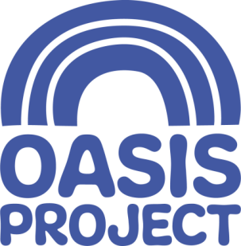

Chair of Board of Trustees
Voluntary, unpaid position – expenses paid
Approximately 10-12 hours per month
Minimum role commitment of 3 years
Meetings are generally held in Brighton but travel to other Sussex locations may be occasionally required

Who we are:
For 21 years Oasis Project (Oasis) has delivered services for women with drug and alcohol problems and children affected by drug use in the family. We are an innovative, creative and forward thinking organisation, which aims to empower women, children and young people affected by substance misuse. We give help and hope to women and children affected by drug and alcohol problems.

About the role:
The role of Chair of the Board of Trustees is a key opportunity to lead the Board of a progressive and ambitious charity, working with a dynamic team, and to play an important role in ensuring the future of Oasis and women’s and family-focused drug and alcohol services in Sussex. You will be an inspirational leader with excellent strategic skills and have a good understanding of the health and social care sector and a passion for feminism and the work that Oasis does.
What you will do:
The Chair will act as an ambassador for our work at the highest levels, support Oasis’ fundraising activities and lead the strategic direction and governance of the organisation through ensuring excellent, well-rounded and carefully considered decision-making. You will have a background in strategy, governance, finance, HR, and/or fundraising and have some experience as a Trustee or Chair previously. You will be available to attend all board meetings, as well as contribute to other relevant committees and take part in occasional fundraising or all-staff events.
You will:
- Have good understanding of the legal duties and responsibilities of being a Trustee at a charity
- Be able to balance tact and diplomacy with a willingness to challenge and constructively criticise
- Be committed to the aims, values and objectives of Oasis
- Have a forward looking vision and ability to confidently lead and develop clear strategy
- Be able to offer independent judgement, impartiality and the ability to think creatively
- Have excellent, clear communication and interpersonal skills and the ability to respect confidences
- Be experienced at chairing meetings and leading useful discussion.

What we offer:
- Supportive induction to the organisation
- Clear communication and competent, organised arrangements for meetings
- Training and learning as required

For a full role description, person specification please visit our website www.oasisproject.org.uk; or you can email recruitment@oasisproject.org.uk. If you would like to talk to someone about our organisation or the role please contact our CEO, Jo-Anne Welsh on 01273 696970.

To apply please submit a CV and covering letter explaining why you believe you fit the post criteria to recruitment@oasisproject.org.uk.

- Closing date for applications is 5 pm on Friday 13 September
- Once your application has been shortlisted it is expected that you attend Oasis Project for an informal visit, on a date and time convenient to yourself and us between 16th and 27th September, to meet with our Head of Client Services and Head of Business Development, and have a show-round the project.
- Final selection will be made via an interview process. Date for interviews is Monday 30 September.

Charity no: 1065503 Company no: 3447762
Oasis is committed to equal opportunities and welcomes applications from people with relevant life as well as professional experience, and those with disabilities who are currently under-represented in the organisation. People from Black and Minority Ethnic communities are underrepresented in our organisation and we particularly welcome applications from this group.

