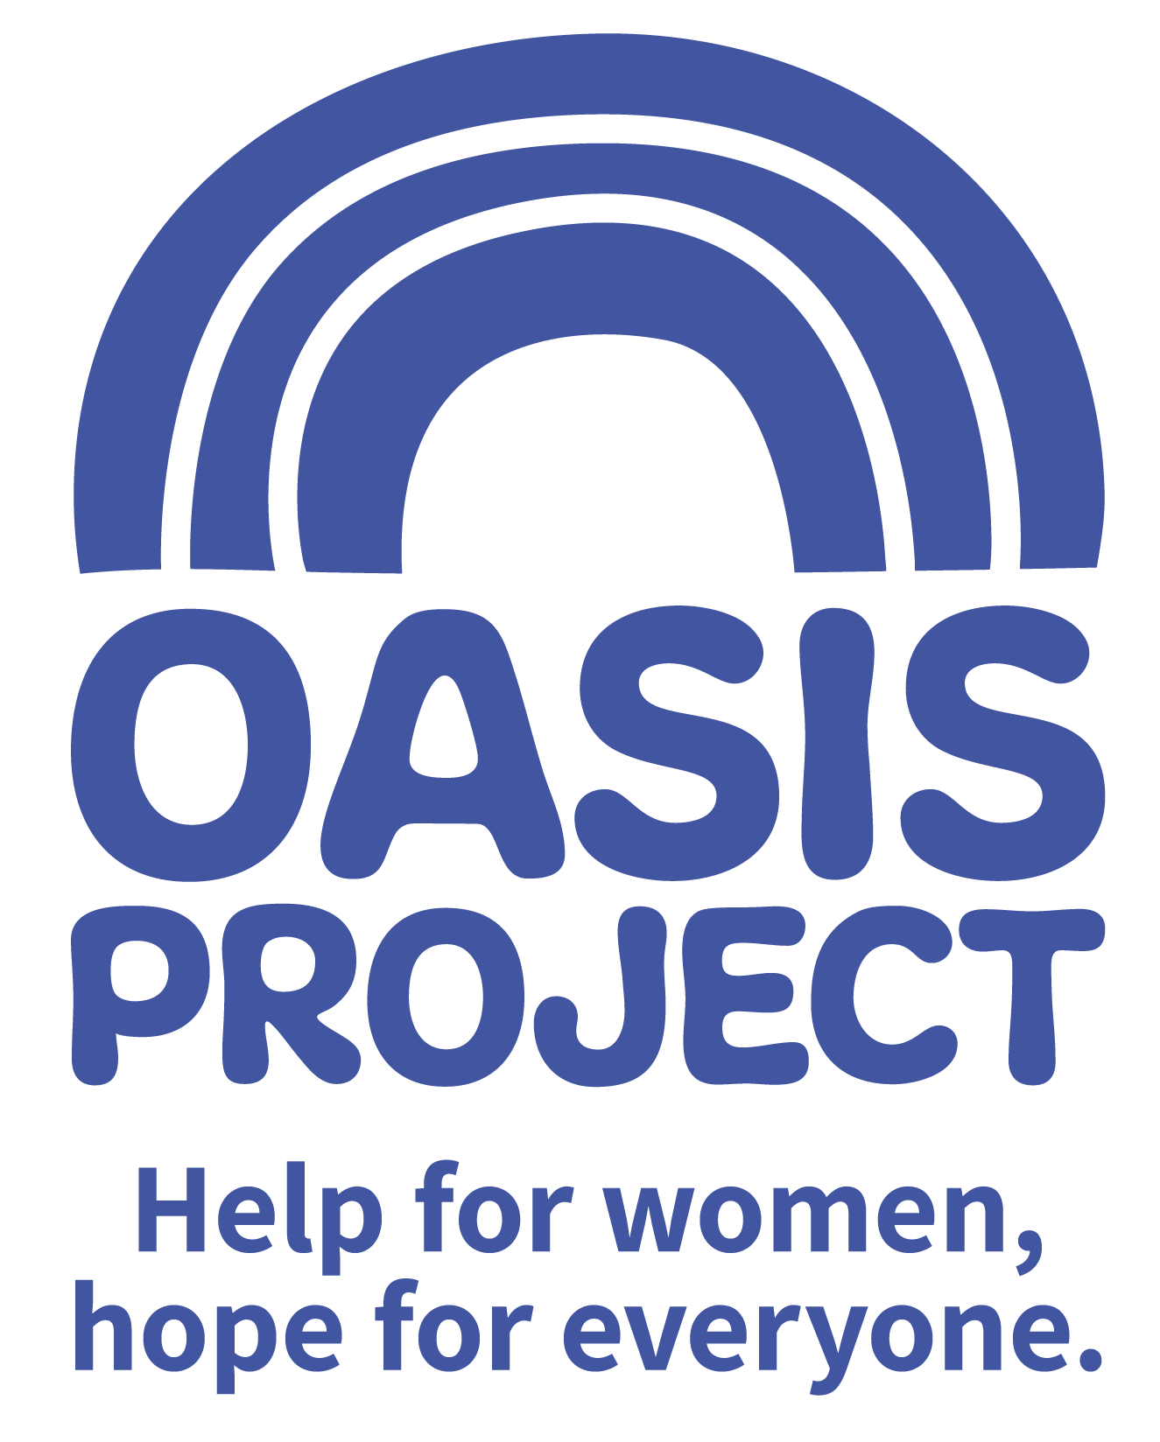

Early Years Practitioner

£9.00 per hour

Working patterns to be agreed with successful candidate/s



Thank you for your interest in Oasis Project and the role of Early Years Practitioner.

This is your application pack. It will tell you about our activities and how you can apply for this role. After reading the pack we hope you will still be interested in applying and ask that you complete the application form and return it to us:

- By email to recruitment@oasisproject.org.uk
- Send by post to Globe House, 3 Morley Street, Brighton, BN2 9RA

Closing date for applications is 10am on Monday 24 June 2019.

Interviews will take place 28 June in Brighton

We hope the successful candidate will be able to start as soon as possible, once recruitment checks are completed.

You will find the following enclosed within this pack:

- Introduction to Oasis Project
  - Core Truths
  - Values

- Working at Oasis Project

- The recruitment process

  - Selection
  - Job description and person specification
  - Completing your application
  - Submitting your completed application
  - References, occupational health checks, UK work eligibility checks and DBS disclosure

Introduction to Oasis Project
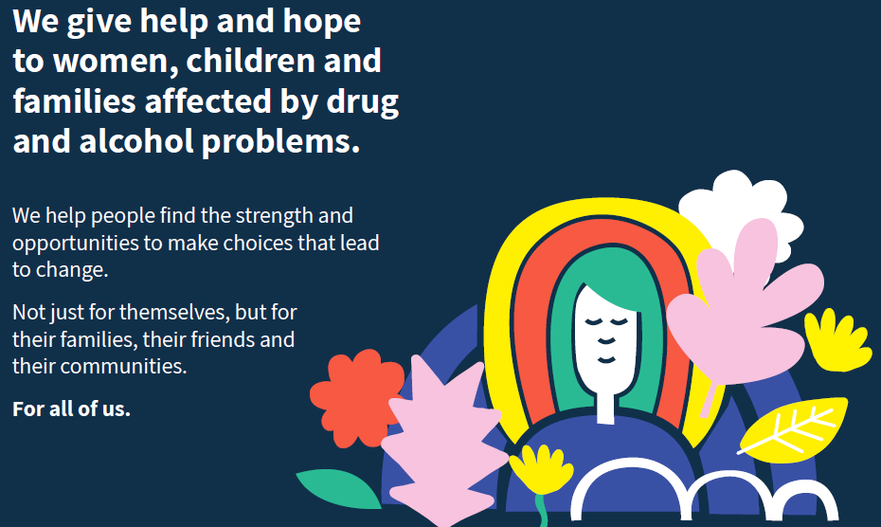

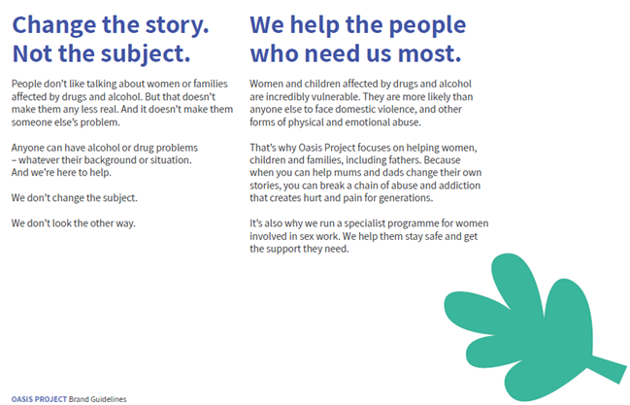

We have identified 7 Core Truths about our organisation. These are:
- Anybody can develop a problem with drink or drugs – whatever their background or situation.
- It is harder for women to escape drug and alcohol problems – they need specialist help.
- Drug and alcohol problems don’t just affect the individual – but everyone around them.
- Drink and drug problems aren’t just the cause of a difficult life, they’re a symptom of one.
- A bad start in life doesn’t have to mean a bad end.
- We’re not here to ‘fix’ anyone – we’re here to help women make choices that lead to change.
- We know that one size doesn’t fit all – we look at the individual

We have also identified 6 key values of our organisation that reflect what we do and how we deliver our services.
Equality
We are a champion for equality, providing a non-judgemental service which respects the needs of its clients in all their diversity and recognises that one size does not fit all.
Accountability
We do what we say we are going to do and work with integrity, never losing sight of our responsibility for our actions
Caring
We deliver all our services with respect for individuals and our day to day interactions are characterised by compassion and kindness
Creativity
We use our unique insight and experience to problem solve, recognising the value of innovation when working with individuals and families
Collaboration
We work together with our clients, their families, friends and networks and our professional partners to provide the best care possible, to keep people safe and to bring about positive change
Learning
We continue to develop and evolve our services to better meet the needs of our clients, facilitating involvement and feedback at every opportunity
The above values are underpinned by a 7th value: Community.

Working at Oasis Project:
Our vision and values underpin the services provided and how they are delivered to clients, as well as to how its employees and volunteers are treated.

We are a small to medium sized organisation. We have approximately 50 employees working a range of flexible hours. This means we are small enough to encourage collaborative working, learning from each other, make decisions quickly and enjoy working in a dynamic and exciting environment. We welcome the views of everyone within the team regardless of length of service and will value your views, perspectives and opinion.

Whilst we enjoy working as a team, the organisation has some key areas of work.
- Young Oasis team (made up of the crèche, therapy services for young people, and young women’s alcohol services)
- Adult services team
- Sex workers outreach project
- Fulfilling Lives Project in East Sussex
- Oasis Women’s Recovery Service in East Sussex
- Smaller short term projects
- Administrative and evaluation functions.

As a paid employee at Oasis, you will be expected to:
- Meet the skills and requirements as outlined in the job description and person specification for this role;

- Make sure that you can commit to the specific hours and days of work that the role requires;

- Make sure that you are able to travel to and from the Brighton Oasis project offices based at 11 Richmond Place, Brighton and at Globe House, 3 Morley Street, Brighton (or other work venue as required).

- Discuss and agree any support needed with your line manager

- Observe the relevant requirements of all Oasis Project policies.

In return you can expect:
Challenge and experience

This role offers a fantastic step to develop your career and make your mark in the organisation. You will be able to make a significant and immediate contribution. The role has its own challenges and pressures but you will receive reward and satisfaction through knowing that your hard work and passion for the role has enhanced the organisation’s professionalism and provided evidence of its value and its ability to meet and exceed all external standards.

Training and support

Oasis Project provides you with regular one to one sessions with your line manager, individual and group supervision sessions, and an annual appraisal to review progress and identify areas for development. We strongly encourage continuous professional development and varied ways of learning.

We like to develop talent and provide opportunities such as secondments to ensure our employees continue to grow and learn, and can remain motivated and passionate about their work.

Benefits

In return for your time and skills at work you will receive
- a fair salary, comparable with similar roles in the area.
- 28 days annual leave plus bank/public holidays pro rata if not full time
- Monthly Well-being hour
- Training and learning opportunities
- Study leave for approved courses/training
- An employer contribution of 3% into our stakeholder pension scheme via Bluesky (on condition that you remain enrolled in the pension scheme and contribute a minimum of 5% of your salary).
- Free tea and coffee
- Occupational health – eye tests reimbursed; other health support provided as necessary.

Career and other benefits

Oasis Project aims to be an employer of choice. We are a professional, well-respected organisation and showing that you have been employed here is great experience to put on your CV. We hold the Investors in People external accreditation.
Insurance

All employees are covered by Oasis Project’s insurance policy. To ensure that you have adequate cover it is important that you follow the guidelines of your role at all times.

THE RECRUITMENT PROCESS

At Oasis Project we are committed to providing the best possible recruitment service including working to remove barriers to equal opportunity at each stage of the recruitment process. Our commitment to you is that:

- We will treat you in a polite, helpful and friendly manner at all times.
- Information that you provide will be treated as confidential and will be seen only by those involved in the recruitment process.

- We will remove all personal information from your application to ensure that the short listing panel are not aware of whose application they are assessing.

- We will ask you to complete an equal opportunities questionnaire – this information is only used for monitoring purposes.

- We will endeavour to make any reasonable adjustments to the selection process (application form, interview or training) to enable individuals to participate equally

- If you are selected to progress to the next stage you will be advised as soon as possible.

- We will aim to give you at least one week’s notice prior to interview, or we will make it clear in the job advertisement when the interviews will be held.

- We will not contact your referees unless you give your permission. We will however need to obtain 2 satisfactory references as a condition of any employment offer.

- A decision will be made as soon as possible after interviews and you will be informed, normally within 1 week.

- Unsuccessful interviewees will be offered feedback.

Selection

Step 1: The first step is to fill in an application form before the closing date. Once you’ve submitted your application form, we will assess whether or not you have demonstrated that you meet the criteria detailed on the person specification for the role.

Step 2: If you are shortlisted at the application stage, the second step will be that you are invited to attend an interview where we will assess whether you’re suitable for the role. You will be sent an interview invitation via email or letter. At the interview you will need to demonstrate that you can meet the criteria in the person specification. Interviews will be held on 19 November 2018.

Step 3: If you’re selected, the third step is that you will undertake a thorough induction and complete the mandatory training programme.

Completing your application
You will need to download an application form. You can download this from the same page where you accessed this recruitment information pack. You can find information about all BOP’s vacancies here: http://www.oasisproject.org.uk/job-vacancies/

You may submit either a typed or hand-written application and send this via email or in the post. If you decide to hand-write your application please ensures that it is legible. Please ensure that your personal information is completed including a contact telephone number if possible.

Please note that we do not accept CVs.

In your application you will need to demonstrate that you have the skills to meet the requirements of the role. Please read the job description and person specification carefully and address your supporting statement to the stated criteria.

It is important and very helpful if you can complete the Equal Opportunities Monitoring form as this helps us to monitor our recruitment process and ensure that we are attracting a diverse range of people to want to work and volunteer at Oasis.

Submitting your application

By email: Please email your completed application form and equal opportunity form to recruitment@oasisproject.org.uk

By post: Please send your completed application form and equal opportunity form to: Administration Manager, Globe House, 3 Morley Street, Brighton, BN2 9RA

Methods of assessment

A range of methods, (although the same for each person) will be used to assess each application that is received for the role. These will include:
- Application form and supporting statement
- Checking qualifications against certificates / registrations with professional bodies
- Interview
- Possible test (such as typing test, report writing, data entry, presentation). You will be informed in advance if a test will be used during an interview process.
- References

Recruitment checks:

References
We require two references. They will not be contacted without your permission but we will need
to obtain two satisfactory references before you can take up any employment offered to you. If
you can provide an email address for your referees this is helpful.

Eligibility to work in the UK
We require you to provide appropriate ID documentation that proves your eligibility to work in
the UK.

Occupational health check
You will be asked to complete an online medical questionnaire, via our occupational health
providers. Our occupational health experts will confirm to Oasis Project whether you are fit (or
not fit) to undertake the role, or if adjustments may be required, based on the information that
you have disclosed.

Ex-offenders / Disclosure and Barring Service (DBS) Checks
All applicants are required to disclose details of any unspent convictions in accordance with the
Rehabilitation of Offenders Act 1974. Any disclosure of an unspent conviction will NOT
automatically disqualify your application unless the nature of the offence renders you unsuitable
for the role. All such disclosures will be considered on an individual basis. There is space on the
application form for this information.

If your employment at Oasis will include working with children and vulnerable adults you will
be required to undertake a DBS check (with the costs for this being met by Oasis).

We wish you success with your application.
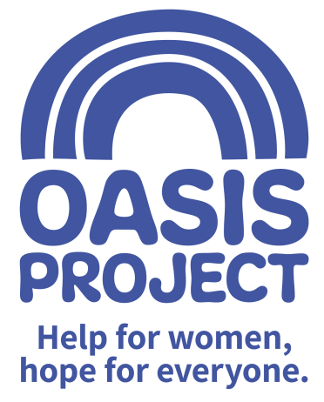

ROLE PROFILE
ROLE TITLE: EARLY YEARS PRACTITIONER | REPORTS TO: Early Years Supervisor
TEAM: Young Oasis | SALARY: £9.00 per hour (B&H Living Wage)
RESPONSIBLE FOR: No line management responsibilities | HOURS: tbc

SUMMARY:

You will be a creative, caring and enthusiastic person who loves working with children. You will contribute to ensuring that the crèche provides a welcoming, happy and safe environment where every child is settled and making good progress from their individual starting point. Children who attend the Oasis crèche can be particularly vulnerable and you will be responsible for ensuring safeguarding procedures are prioritised at all times, following all safeguarding procedures. You will be a confident communicator and enjoy working in a team. You will demonstrate a keen interest in learning and development. You will take on supervisory responsibilities at times to cover days off and annual leave.

Early Years and crèche provision
- To contribute to providing a high standard of physical, emotional, social and intellectual care and development for children within the crèche
- To contribute to ideas for the yearly programme of activities and fulfil this
- To help identify the physical, emotional, intellectual developmental needs of each child and offer appropriate support and relevant developmental opportunities, including updating records.

Safeguarding
- Demonstrates confidence and understanding in safeguarding procedures

Communication
- Can be a confident communicator and good listener.

Team player
- Will demonstrate enthusiasm and positivity within the crèche team and wider organisation
- Will contribute and actively engage in crèche team meetings
- Will take on supervisory responsibility in the crèche occasionally to cover absence

General accountabilities
To meet all other expectations of the role by:-
- Demonstrating commitment to the vision and values of Oasis and an understanding how own behaviour and actions contribute to maintaining a culture of shared ownership and responsibility that supports Oasis in achieving its overall vision
- Demonstrating awareness and commitment to working in a way that is ‘trauma informed’ and to recognise this approach as part of BOP’s overall commitment to providing gender responsive services for women.
- Maintaining awareness of all current Health and Safety legislation and demonstrate a commitment to working within and promoting safe practice;
- Promoting and embracing all aspects of equality and diversity;
- Following and adhering to all policy and procedure within the organisation particularly confidentiality and data protection guidelines;
- Actively participating in all appropriate meetings and training and learning opportunities;
- Providing timely and appropriate feedback through supervision sessions, and actively participating in these sessions;
- Supporting, promoting and working in accordance with all of BOP’s aims and objectives;
- Carrying out from time to time any other appropriate duties as directed by management to support and promote the work of BOP, in accordance with the post holder’s capabilities.

PERSON SPECIFICATION | Essential or Desirable
QUALIFICATIONS
Level 2 childcare qualification or degree in Early Years | Essential
Working towards or willing to work towards Level 3 childcare qualification | Essential
First Aid (general) | Desirable
First Aid (pediatrics) | Desirable
KNOWLEDGE, SKILLS AND EXPERIENCE
At least 1 year relevant significant experience of working with children and families in an early years setting | Essential
Demonstrable experience of safeguarding children legislation and processes | Essential
Experience of implementing a varied range of activities with children and generating new activities and creative ideas. | Essential
Skilled at using Microsoft office packages including outlook, word, powerpoint | Essential
Experienced at communicating clearly and confidently to a range of audiences | Essential
Knowledge and understanding of the current EYFS curriculum | Desirable
An understanding of current issues related to substance misuse and families experiencing problems | Desirable
To have an understanding of working in a way that is ‘trauma informed’ | Desirable
ATTITUDE AND BEHAVIOURS
To demonstrate an enthusiastic and motivating attitude | Essential
An understanding and commitment to the principles of equality and diversity and an ability to engage with children and adults from diverse backgrounds. | Essential
To understand the importance of taking responsibility for own behavior and actions | Essential
To be aware of best practice around confidentiality procedures and a clear understanding of data protection guidelines | Essential
Committed to continued professional development including active participation in internal and external meetings and training | Essential

The post is subject to the satisfactory completion of a Disclosure and Barring Service check at an enhanced level.
This job description accurately reflects the present position; it may be reviewed and amended but only after a proper period of consultation.

