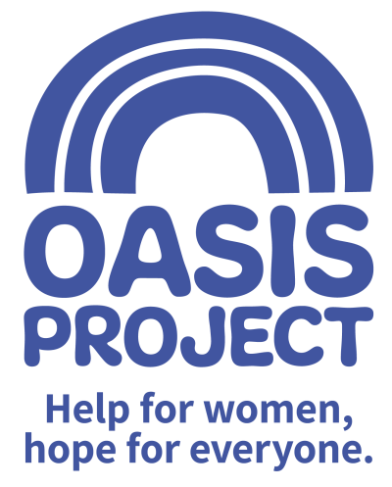

Equal opportunities monitoring form

Unique identification number:
(For office use only)

Post applied for:

We are an equal opportunity employer. The aim of our policy is to ensure that no job applicant or employee receives less favourable treatment because of age, disability, gender reassignment, marriage and civil partnership, pregnancy or maternity, race, religion or belief, sex or sexual orientation.

To ensure that this policy is fully and fairly implemented and monitored, and for no other reason, would you please provide the following information:

Age

- Prefer not to say
- School age
- Over school age - 17
- 18-24
- 25-34
- 35-44
- 45-54
- 55-64
- 65-74
- 75+
Disability
Do you have a disability?

- Prefer not to say
- Yes, I am aware I have a disability
- No, I don’t have a disability
- As far as I am aware, I don’t have a disability

You will be considered as having a disability for discrimination purposes if you fit the definition as given in the Equality Act 2010. In the Act, a disability is a ‘physical or mental impairment which has a substantial and long term adverse effect on a person’s ability to carry out normal day to day activities.’ For these purposes, ‘long term’ is taken to mean the condition is likely to last longer than 12 months or likely to recur.

Ethnicity
- Prefer not to say

Asian or Asian British
- Bangladeshi
- Indian
- Pakistani
- Other Asian background (Please specify ____________________________)

Black or Black British
- African
- Caribbean
- Other Black background (Please specify ____________________________)

Chinese and other groups
- Chinese
- Other ethnic group (Please specify ____________________________)

Mixed race
- White and Asian
- White and Black African
- White and Caribbean
- Other Mixed background (Please specify ____________________________)

White
- British
- Irish
- Other White background (Please specify ____________________________)

Religion or belief
- Prefer not to say
- Buddhist
- Christian
- Hindu
- Jewish
- Muslim
- Sikh
- Other (Please specify ____________________________)
- No religion

Gender
- Prefer not to say
- Male
- Female

Sexual orientation
- Prefer not to say
- Lesbian
- Gay man
- Bisexual
- Heterosexual/straight

Data protection statement

Data Controller name: Oasis Project
The Company uses this information to review compliance with its policies on equal opportunity in relation to recruitment. We will use this data to inform our statistics on the representation of the categories of individual as shown above. We will treat all personal information in line with current data protection legislation and our data protection policy. For more information on how we use the information you have provided, please see our privacy notice on our website. http://www.oasisproject.org.uk/information/your-privacy/

In order for us to process this information and to comply with data protection legislation, we require your consent. You are not required to give your consent; you acknowledge that any consent given is freely given. Your job application is not dependent on your giving consent to our processing of this data.

Including your signature below will signify your consent to our processing of this information. Once you have given consent, you may withdraw it at any time by contacting Human Resources, Oasis Project, Globe House, 3 Morley Street, Brighton, BN2 9RA

Signature:
Date:

