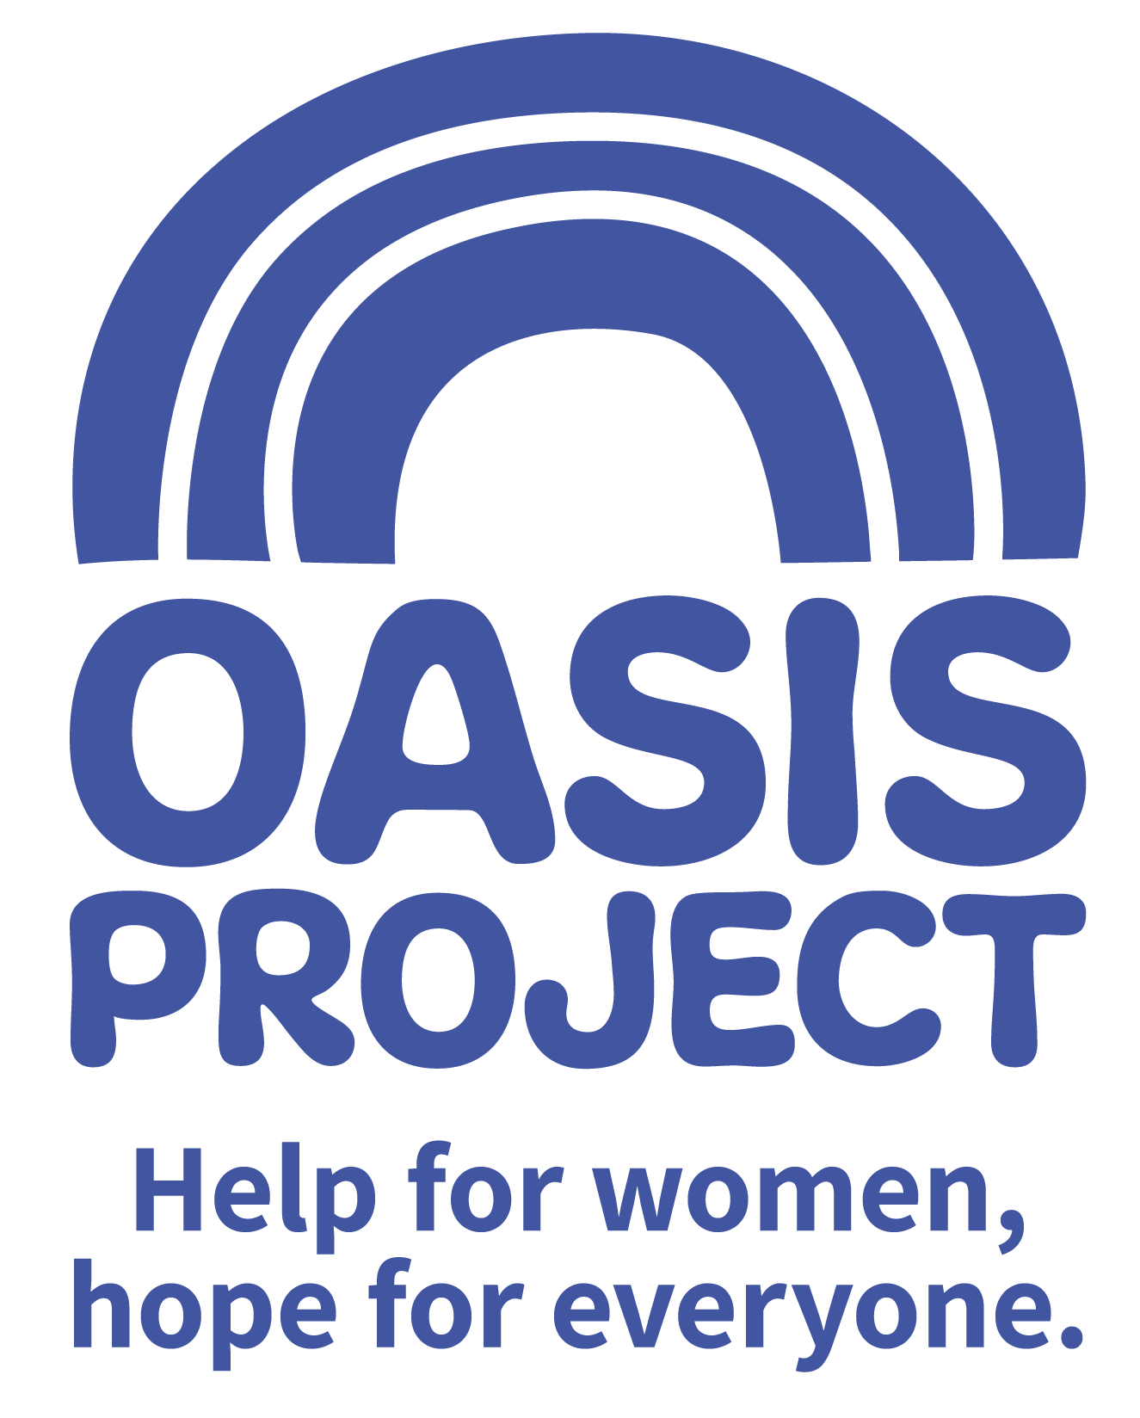

Fundraising Assistant

£17,000 per year FTE
15 hours per week over 2 days with occasional evening and weekend work
The role is a fixed term contract until 31 March 2020

Based in Brighton but travel to other Sussex locations occasionally required

Thank you for your interest in Oasis Project and the role of Fundraising Assistant

This is your application pack. It will tell you about our activities and how you can apply for this role. After reading the pack we hope you will still be interested in applying and ask that you complete the application form and return it to us:

- By email to recruitment@oasisproject.org.uk
- Send by post to Globe House, 3 Morley Street, Brighton, BN2 9RA

Closing date is 5pm on 9 May 2019

Interviews will be held on 16 May 2019. The interview process will involve a series of competency based interview questions.

We hope the successful candidate will be able to start as soon as possible, once recruitment checks are completed.

You will find the following enclosed within this pack:

- Introduction to Oasis Project

- Working at Oasis Project

- The recruitment process

  - Selection
  - Job description and person specification
  - Completing your application
  - Submitting your completed application
  - References, occupational health checks, UK work eligibility checks and DBS disclosure

Introduction to Oasis Project
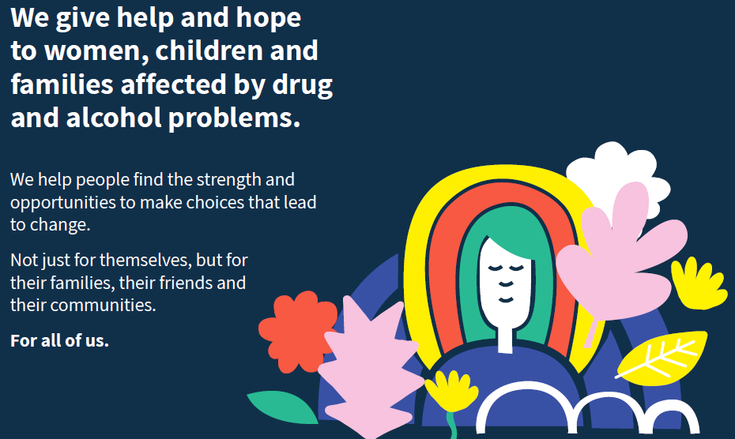

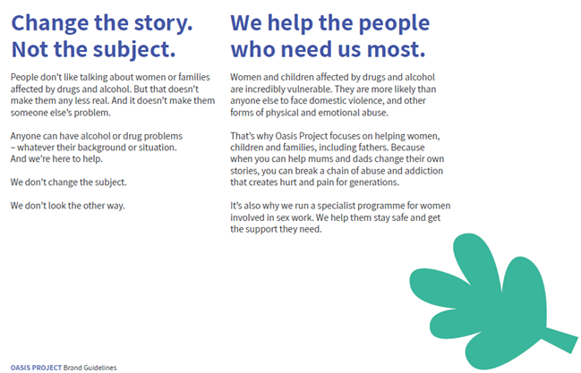

Working at Oasis Project:

Our vision and values underpin the services provided and how they are delivered to clients, as well as to how its employees and volunteers are treated.

We are a small to medium sized organisation. We have approximately 50 employees working a range of flexible hours. This means we are small enough to encourage collaborative working, learning from each other, make decisions quickly and enjoy working in a dynamic and exciting environment. We welcome the views of everyone within the team regardless of length of service and will value your views, perspectives and opinion.

Whilst we enjoy working as a team, the organisation has some key areas of work.
- Young Oasis team (made up of the crèche, therapy services for young people, and young women’s alcohol services)
- Adult services team
- Sex workers outreach project
- Fulfilling Lives Project in East Sussex
- Smaller short term projects
- Administrative and fundraising functions.

As a paid employee at Oasis, you will be expected to:
- Meet the skills and requirements as outlined in the job description and person specification for this role;

- Make sure that you can commit to the specific hours and days of work that the role requires;

- Make sure that you are able to travel to and from the Brighton Oasis project offices based at 11 Richmond Place, Brighton and at Globe House, 3 Morley Street, Brighton (or other work venue as required).

- Discuss and agree any support needed with your line manager or the Director of the project and/or the Human Resources Adviser.

- Engage with a culture of continuous professional development

- Observe the relevant requirements of all Oasis Project policies.

In return you can expect

Challenge and experience

This role offers a fantastic step to develop your career and make your mark in the organisation. It is a new role so you will be able to develop it and make a significant and immediate contribution.

Training and support

Oasis Project provides you with regular one to one sessions with your line manager and an annual appraisal to review progress and identify areas for development. We also strongly encourage continuous professional development and encourage learning from a range of different opportunities.

We like to develop talent and provide opportunities such as secondments to ensure our employees continue to grow and learn, and can remain motivated and passionate about their work.

Benefits

In return for your time and skills at work you will receive
- a fair salary, comparable with similar roles in the area.
- 28 days (210 hours) annual leave plus bank/public holidays pro rata (full time) or pro rata equivalent
- Training and learning opportunities
- Study leave for approved courses/training
- An employer contribution of 3% into our stakeholder pension scheme via Bluesky (on condition that you remain enrolled in the pension scheme and contribute a minimum of 5% of your salary).
- Free tea and coffee
- Occupational health – eye tests reimbursed; other health support provided as necessary.

Career and other benefits

Oasis Project aims to be an employer of choice. We are a professional, well-respected organisation and showing that you have been employed here is great experience to put on your CV. We hold the Investors in People external accreditation.
Insurance

All employees are covered by Oasis Project’s insurance policy. To ensure that you have adequate cover it is important that you follow the guidelines of your role at all times.

THE RECRUITMENT PROCESS
At Oasis Project we are committed to providing the best possible recruitment service including working to remove barriers to equal opportunity at each stage of the recruitment process. Our commitment to you is that:

- We will treat you in a polite, helpful and friendly manner at all times.
- Information that you provide will be treated as confidential and will be seen only by those involved in the recruitment process.

- We will remove all personal information from your application to ensure that the short listing panel are not aware of whose application they are assessing.

- We will ask you to complete an equal opportunities questionnaire – this information is only used for monitoring purposes.

- We will endeavour to make any reasonable adjustments to the selection process (application form, interview or training) to enable individuals to participate equally

- If you are selected to progress to the next stage you will be advised as soon as possible.

- We will aim to give you at least one week’s notice prior to interview, or we will make it clear in the job advertisement when the interviews will be held.

- We will not contact your referees unless you give your permission. We will however need to obtain 2 satisfactory references as a condition of any employment offer.

- A decision will be made as soon as possible after interviews and you will be informed, normally within 1 week.

- Unsuccessful interviewees will be offered feedback.

Selection
Step 1: The first step is to fill in an application form before the closing date. Once you’ve submitted your application form, we will assess whether or not you have demonstrated that you meet the criteria detailed on the person specification for the role.

Step 2: If you are shortlisted at the application stage, the second step will be that you are invited to attend an interview where we will assess whether you’re suitable for the role. You will be sent an interview invitation via email or letter. At the interview you will need to demonstrate that you can meet the criteria in the person specification. Interviews will be held on 19 November 2018.

Step 3: If you’re selected, the third step is that you will undertake a thorough induction and complete the mandatory training programme.

Completing your application
You will need to download an application form. You can download this from the same page where you accessed this recruitment information pack. You can find information about all BOP’s vacancies here: http://www.oasisproject.org.uk/job-vacancies/

You may submit either a typed or hand-written application and send this via email or in the post. If you decide to hand-write your application please ensures that it is legible. Please ensure that your personal information is completed including a contact telephone number if possible.

Please note that we do not accept CVs.

In your application you will need to demonstrate that you have the skills to meet the requirements of the role. Please read the job description and person specification carefully and address your supporting statement to the stated criteria.

It is important and very helpful if you can complete the Equal Opportunities Monitoring form as this helps us to monitor our recruitment process and ensure that we are attracting a diverse range of people to want to work and volunteer at Oasis.

Submitting your application

By email: Please email your completed application form and equal opportunity form to recruitment@oasisproject.org.uk

By post: Please send your completed application form and equal opportunity form to: Administration Manager, Globe House, 3 Morley Street, Brighton, BN2 9RA

Methods of assessment
A range of methods, (although the same for each person) will be used to assess each application that is received for the role. These will include:
- Application form and supporting statement
- Checking qualifications against certificates / registrations with professional bodies
- Interview
- Possible test (such as typing test, report writing, data entry, presentation). You will be informed in advance if a test will be used during an interview process.
- References

Recruitment checks:

References
We require two references. They will not be contacted without your permission but we will need
to obtain two satisfactory references before you can take up any employment offered to you. If
you can provide an email address for your referees this is helpful.

Eligibility to work in the UK
We require you to provide appropriate ID documentation that proves your eligibility to work in
the UK.

Occupational health check
You will be asked to complete an online medical questionnaire, via our occupational health
providers. Our occupational health experts will confirm to Oasis Project whether you are fit (or
not fit) to undertake the role, or if adjustments may be required, based on the information that
you have disclosed.

Ex-offenders / Disclosure and Barring Service (DBS) Checks
All applicants are required to disclose details of any unspent convictions in accordance with the
Rehabilitation of Offenders Act 1974. Any disclosure of an unspent conviction will NOT
automatically disqualify your application unless the nature of the offence renders you unsuitable
for the role. All such disclosures will be considered on an individual basis. There is space on the
application form for this information.

If your employment at Oasis will include working with children and vulnerable adults you will
be required to undertake a DBS check (with the costs for this being met by Oasis).

We wish you success with your application.
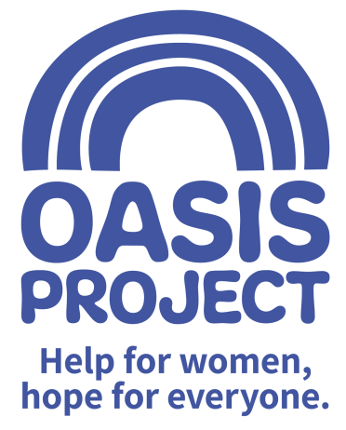

Role profile:
Role title: Fundraising Assistant | Reports to: Head of Business Development
Team: Fundraising | Salary: £17,000 per year FTE
Hours: 15 hours per week worked over 2 days

Contract type: Fixed until end March 2020

Purpose of the role:
To work with in the Oasis Project fundraising team to support the organisation to meet its targets by assisting with securing new income through community fundraising; events, individual giving, online fundraising and corporate fundraising. The role will involve organising events, assisting with fundraising applications and engaging with individuals, groups, clubs and associations to seek support from local and regional companies.

Communicating key messages about Oasis to inspire and engage supporters will be key, as will successful stewardship of new and existing supporters. The post-holder will work alongside the fundraising team, staff and trustees to implement Oasis’ fundraising strategy with the aim of delivering sustainable income.

The successful candidate will be a self-motivated and driven individual with buckets of creativity and enthusiasm. Experience in organising events is essential. The post-holder will be out-going and a passionate advocate and representative of Oasis. A strong competency in communication (both verbal and written) will be key as will the understanding of budgets and general numeracy.

Responsibilities:
Income Generation
- Working with the fundraising team to contribute to a yearly plan of small to medium sized fundraising events and initiatives
- Organising, marketing and running fundraising activities, in particular events, in line with the Oasis branding. Promote these events through a variety of different channels to reach a wider community, deliver outstanding service to attendees and participants at the events
- Identifying key individuals who have the interest and capacity to fundraise for Oasis, supporting them in their activities and/or as they develop their own fundraising groups, including giving presentations on Oasis as necessary and training them to present on our behalf
- Supporting the fundraising team in writing funding proposals to trusts and foundations
- Supporting the delivery of quality and timely thanking, stewardship and reporting back to funders, companies and supporters in order that their support is recognised, retained and repeated.

Communication and relationships
- Creating informative and exciting publicity material and fundraising materials consistent with Oasis branding guidelines
- Acting as a point of contact for all communication regarding fundraising by telephone, email and in person as appropriate
- Supporting the fundraising team to ensure that the Oasis website has a section on fundraising that remains accurate, up to date, and includes content that is uploaded in a timely and professional manner.
- Using social media to promote Oasis’ services and fundraising activity.
- Being a passionate advocate of Oasis’ services and ethos.

Record keeping and finance
- Maintaining up to date accurate records around funders and supporters using a database
- Keeping clear and up to date records of funding adhered to feed into reports to the CEO and the Board of Trustees about fundraising levels and activity
- Be able to work to and exceed targets
Continuous Development
- Reflect on and develop own practice
- Monitor own performance to ensure it meets expectations and performance targets
- Make use of supervision opportunities, ensuring there is two-way dialogue
- Participate in training and other development opportunities
- Contribute to the development and knowledge of others by sharing your experience and skills

Values and Ethos
- Demonstrate commitment to the vision and values of Oasis and understand how your own behaviour and actions impact this
- Contribute to maintaining a culture of shared ownership and responsibility that supports Oasis in achieving its overall mission
- Understand and commit to equality, diversity and inclusion best practice with a particular focus on hard to reach and marginalised women service users
- Be aware of and commit to working in a way that is ‘trauma informed’ and recognise this approach as part of Oasis’ overall commitment to providing gender responsive services
- Observe professional boundaries in relationships with service users, peers and other relevant professionals
- Participate in the continuous improvement of Oasis’ services

Compliance
- Ensure that Oasis and its services are represented in a professional manner at all times
- Meet agreed performance targets and outcomes
- Use management information and data as appropriate
- Comply at all times with health and safety regulations
- Ensure risk assessments are completed as appropriate
- Take personal responsibility for own safety
- Comply with all relevant policy and procedure, standards and codes of conduct
- Meet all regulatory requirements
- Comply with Oasis’ policy and procedure particularly confidentiality and data protection guidance
- Use IT and databases to keep records up to date in line with agreed processes
- Undertake any other reasonable duties as requested by the line manager

PERSON SPECIFICATION | Essential or Desirable
Minimum of 5 GCSE Grade C or above (or equivalent) including English and Maths | Essential
Experience of working in a fundraising environment or transferable skills from a sales, marketing or events background | Essential
Comprehensive understanding of Microsoft Office (including Outlook, Word, Excel and Powerpoint) | Essential
Experience of working with administrative systems and using databases to systematically record information and report from it | Essential
Ability to manage multiple priorities in an effective, efficient and organised manner | Essential
Ability to write clear and informative copy for internal and external communication purposes | Essential
Experience organising and managing events | Essential
Good working knowledge and awareness of social media and its uses (Twitter, Facebook and Instagram) | Essential
Experience of working to and exceeding targets | Desirable
Excellent interpersonal, communication and presentation skills | Essential
Confident telephone manner | Essential
Knowledge of local business networks and community groups | Desirable
An understanding of and an interest in the issues surrounding substance misuse and women-only services | Desirable

The post is subject to the satisfactory completion of a Disclosure and Barring Service (DBS - formally CRB) check at an enhanced level. This job description accurately reflects the present position; it may be reviewed and amended but only after a proper period of consultation.

