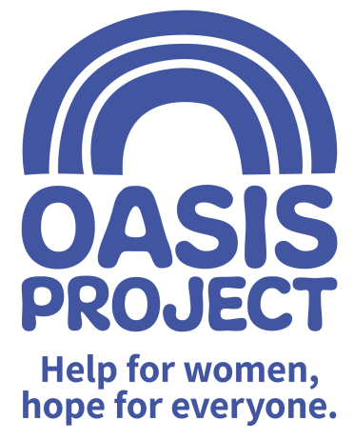

Role profile:
Role title: Fundraising Assistant | Reports to: Head of Business Development
Team: Fundraising | Salary: £17,000 per year FTE
Hours: 15 hours per week worked over 2 days

Contract type: Fixed until end March 2020

Purpose of the role:
To work with in the Oasis Project fundraising team to support the organisation to meet its targets by assisting with securing new income through community fundraising; events, individual giving, online fundraising and corporate fundraising. The role will involve organising events, assisting with fundraising applications and engaging with individuals, groups, clubs and associations to seek support from local and regional companies.

Communicating key messages about Oasis to inspire and engage supporters will be key, as will successful stewardship of new and existing supporters. The post-holder will work alongside the fundraising team, staff and trustees to implement Oasis’ fundraising strategy with the aim of delivering sustainable income.

The successful candidate will be a self-motivated and driven individual with buckets of creativity and enthusiasm. Experience in organising events is essential. The post-holder will be out-going and a passionate advocate and representative of Oasis. A strong competency in communication (both verbal and written) will be key as will the understanding of budgets and general numeracy.

Responsibilities:
Income Generation
- Working with the fundraising team to contribute to a yearly plan of small to medium sized fundraising events and initiatives
- Organising, marketing and running fundraising activities, in particular events, in line with the Oasis branding. Promote these events through a variety of different channels to reach a wider community, deliver outstanding service to attendees and participants at the events
- Identifying key individuals who have the interest and capacity to fundraise for Oasis, supporting them in their activities and/or as they develop their own fundraising groups, including giving presentations on Oasis as necessary and training them to present on our behalf
- Supporting the fundraising team in writing funding proposals to trusts and foundations
- Supporting the deliver quality and timely thanking, stewardship and reporting back to funders, companies and supporters in order that their support is recognised, retained and repeated.

Communication and relationships
- Creating informative and exciting publicity material and fundraising materials consistent with Oasis branding guidelines
- Acting as a point of contact for all communication regarding fundraising by telephone, email and in person as appropriate
- Supporting the fundraising team to ensure that the Oasis website has a section on fundraising that remains accurate, up to date, and includes content that is uploaded in a timely and professional manner.
- Using social media to promote Oasis’ services and fundraising activity.
- Being a passionate advocate of Oasis’ services and ethos.

Record keeping and finance
- Maintaining up to date accurate records around funders and supporters using a database
- Keeping clear and up to date records of funding adhered to feed into reports to the CEO and the Board of Trustees about fundraising levels and activity
- Be able to work to and exceed targets
Continuous Development
- Reflect on and develop own practice
- Monitor own performance to ensure it meets expectations and agreed performance targets
- Make use of supervision opportunities, ensuring there is two-way dialogue
- Participate in training and other development opportunities
- Contribute to the development and knowledge of others by sharing your experience and skills

Values and Ethos
- Demonstrate commitment to the vision and values of Oasis and understand how your own behaviour and actions impact this
- Contribute to maintaining a culture of shared ownership and responsibility that supports Oasis in achieving its overall mission
- Understand and commit to equality, diversity and inclusion best practice with a particular focus on hard to reach and marginalised women service users
- Be aware of and commit to working in a way that is ‘trauma informed’ and recognise this approach as part of Oasis’ overall commitment to providing gender responsive services
- Observe professional boundaries in relationships with service users, peers and other relevant professionals
- Participate in the continuous improvement of Oasis’ services

Compliance
- Ensure that Oasis and its services are represented in a professional manner at all times
- Meet agreed performance targets and outcomes
- Use management information and data as appropriate
- Comply at all times with health and safety regulations
- Ensure risk assessments are completed as appropriate
- Take personal responsibility for own safety
- Comply with all relevant policy and procedure, standards and codes of conduct
- Meet all regulatory requirements
- Comply with Oasis’ policy and procedure particularly confidentiality and data protection guidance
- Use IT and databases to keep records up to date in line with agreed processes
- Undertake any other reasonable duties as requested by the line manager

PERSON SPECIFICATION | Essential or Desirable
Minimum of 5 GCSE Grade C or above (or equivalent) including English and Maths | Essential
Experience of working in a fundraising environment or transferable skills from a sales, marketing or events background | Essential
Comprehensive understanding of Microsoft Office (including Outlook, Word, Excel and Powerpoint) | Essential
Experience of working with administrative systems and using databases to systematically record information and report from it | Essential
Ability to manage multiple priorities in an effective, efficient and organised manner | Essential
Ability to write clear and informative copy for internal and external communication purposes | Essential
Experience organising and managing events | Essential
Good working knowledge and awareness of social media and its uses (Twitter, Facebook and Instagram) | Essential
Experience of working to and exceeding targets | Desirable
Excellent interpersonal, communication and presentation skills | Essential
Confident telephone manner | Essential
Knowledge of local business networks and community groups | Desirable
An understanding of and an interest in the issues surrounding substance misuse and women-only services | Desirable

The post is subject to the satisfactory completion of a Disclosure and Barring Service (DBS - formally CRB) check at an enhanced level. This job description accurately reflects the present position; it may be reviewed and amended but only after a proper period of consultation.

